**Troubleshooting Epicor Learning Center Courses:**

Epicor Learning Center (ELC) supports Chrome or Internet Explorer. If you experience issues with playing courses, you must set the following; following all of these steps ensures optimal playback:

* Disable Pop-up Blockers
* Enable Cookies
* Set the following as trusted Sites:
  + <https://ondemand.epicor.com>
  + <https://cloud.scorm.com>
* Enable Flash

**Browser Specific Help:**

**Chrome:**

Set Trusted Sites:

* Settings > Advanced > System – Open Proxy Settings:
* Select: Security Tab – Trusted sites:

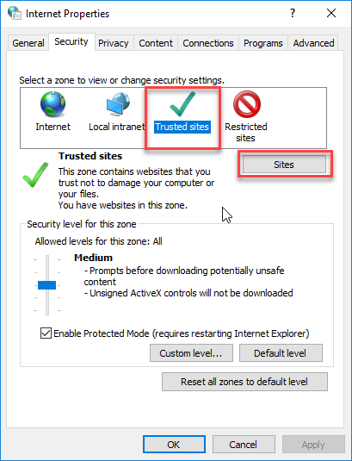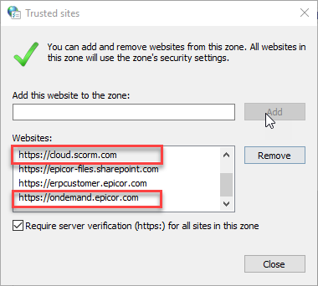

Enable Flash:

* Settings > Advanced > Content Settings – Flash:
* Make sure “Block Sites from Running Flash” (or Ask First in older versions) is set to OFF:

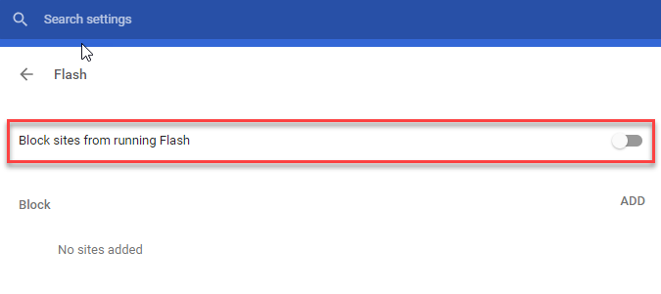

**Internet Explorer:**

Set Trusted Sites:

* Select: Tools > Internet Options
* Select: Security Tab – Trusted sites:



Enable Flash:

* Select: Tools > Manage Add-Ons
* Ensure that Shockwave Flash is listed as currently added

