Name of Course | Setting Up and Using the General Ledger Cross Reference |  |  | EDP-26766
Writer | Anand VM | Reviewers | Kim Stanley
Software Version | 2022.1 | Date | March 8, 2021
Attendee Group |  | Roles | All
Categories | Accounting | Subcategories | Pricing
Course Description | You can map category-based General Ledger accounts to any 3rd party accounting process. After mapping we will view the transaction data using the Group By filter versus GL Transaction detail.
System Screens*  *Required field in CourseTracker | Home, GL Cross Reference, Pricing, EDP-26766

Training snapshot (list the topics to illustrate the topics in the course)
 | Introduction | Name of Topic | Knowledge Check Yes/No
 | Topic A | Setting Up General Ledger Cross Reference
 | Topic B | Using the GL Transaction Viewer
 | Recap

Introduction
 | Narration | Action/Notes
 | If you use a 3rd party accounting software, you can easily map the Propello output to your own chart of accounts. | Setting Up and Using the General Ledger Cross Reference
 | In this course, we will demonstrate how to map the default GL accounts to your specific 3rd party account.  Then we will view the activity in GL Transaction Viewer.  Choose a topic to learn more. | Objectives:  - Setting Up the General Ledger Cross Reference    - Using the GL Transaction Viewer  

Topic A – Setting Up General Ledger Cross Reference
 | Narration | Action/Notes
 | Creating a cross reference allows you to map your own chart of accounts to the related Propello activity.  From the main menu, select Accounting > Setup > GL Cross Reference. | 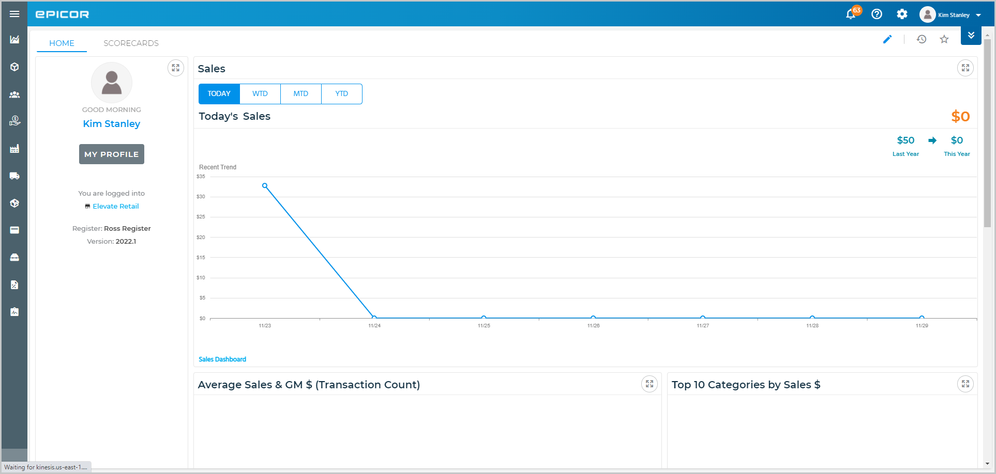  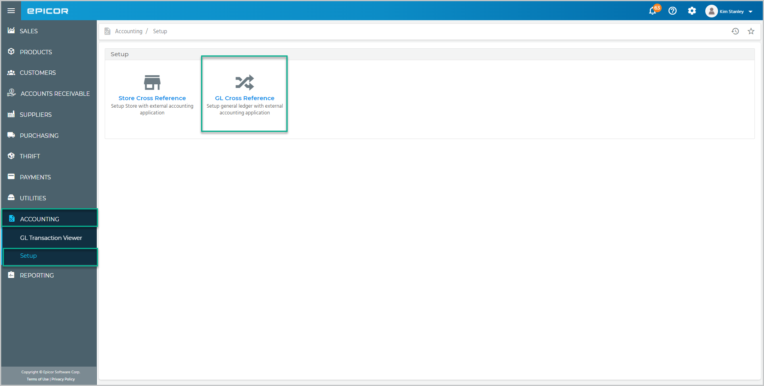
 | Based on the various transactions, you can view the list of GL categories here.  Use the available filters to display a set of specific GL accounts. | 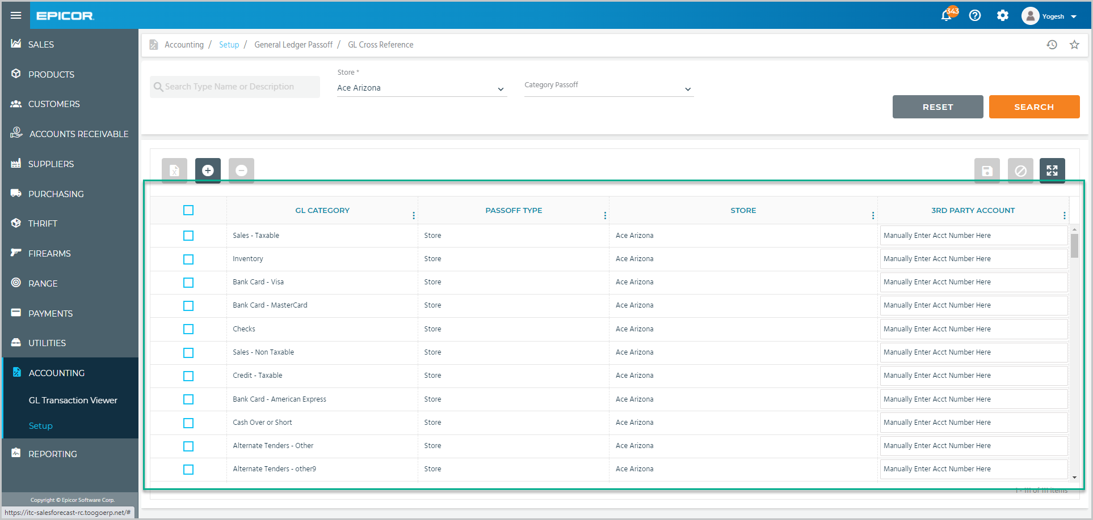  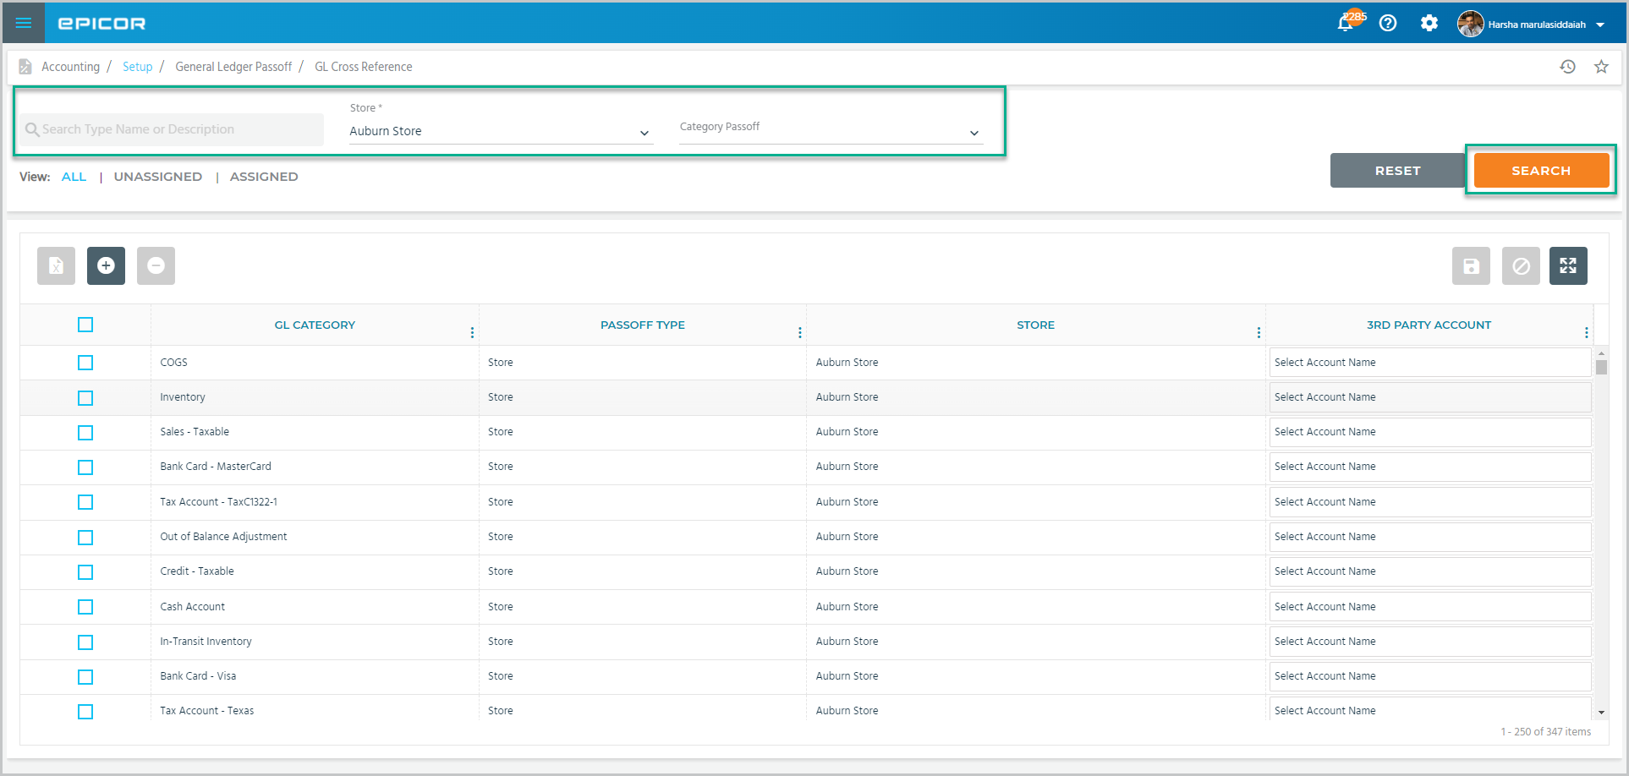
 | Enter your 3rd party account numbers in the 3rd Party Account field for the respective Propello GL Category.  Your account numbers can be alphabetic, numeric, or alpha numeric.  Tap Save when you are ready to apply the changes.  Check the box to select a GL account or check this box to select all accounts.  You can export the data to Excel.  If you want to delete any account, tap Delete. | 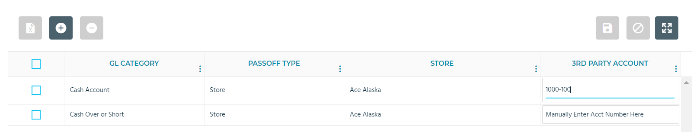  For Cash, add account 1000-100  This is a valid  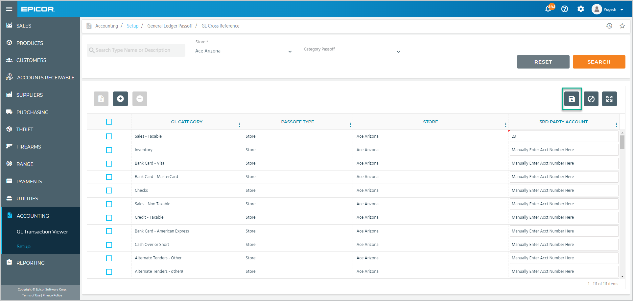  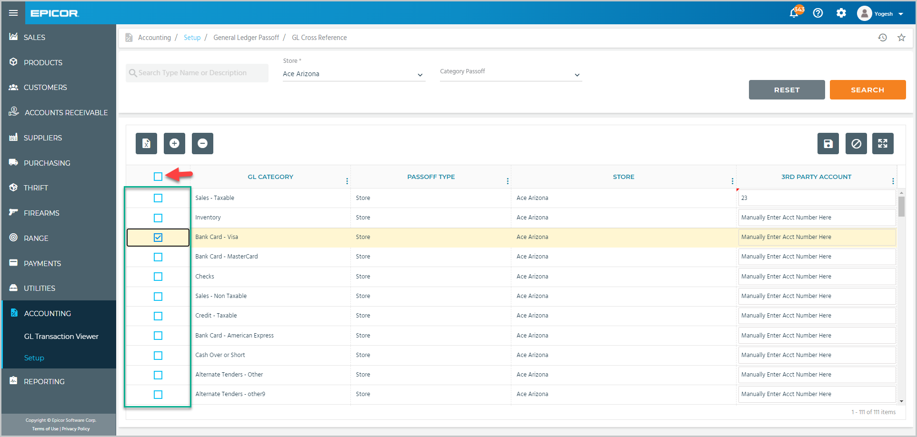  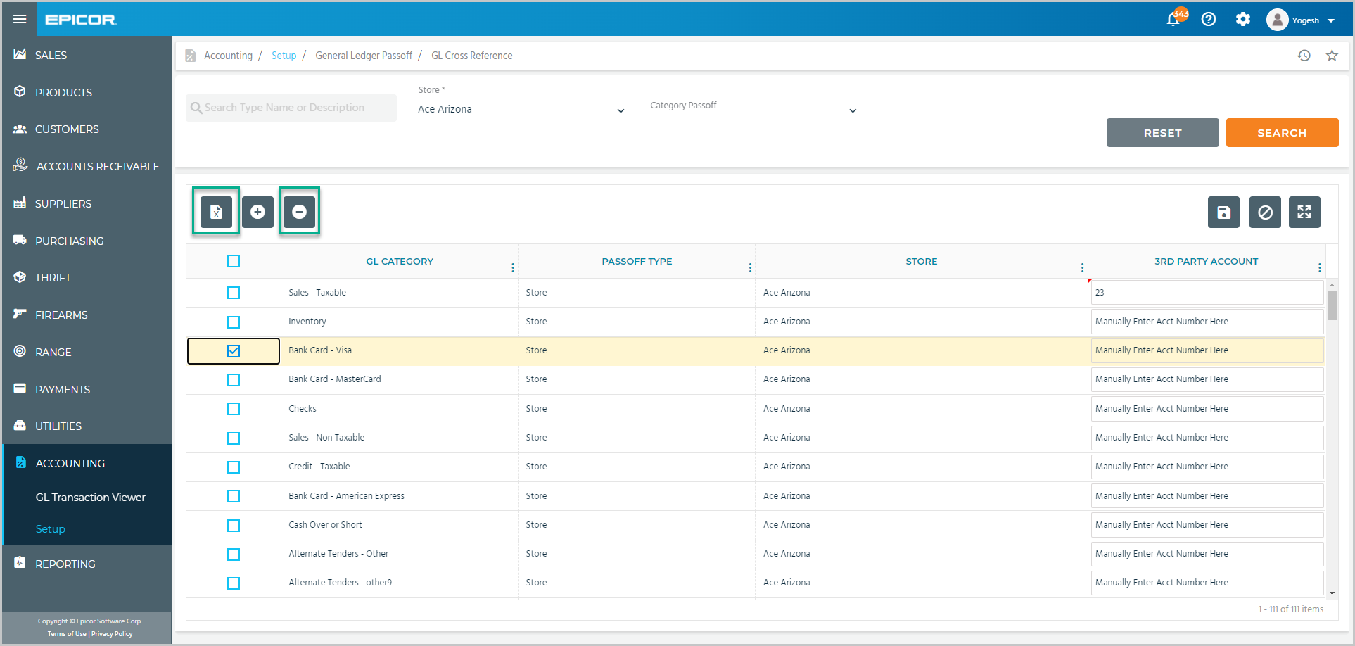
 | You can also tap Add Category Passoff to link your chart of accounts to specific product categories.  Select one from the drop-down list.  Check the boxes to select the Propello GL Category that you want to associate with your GL account number.  Enter that account number like we did before, and tap Save. | 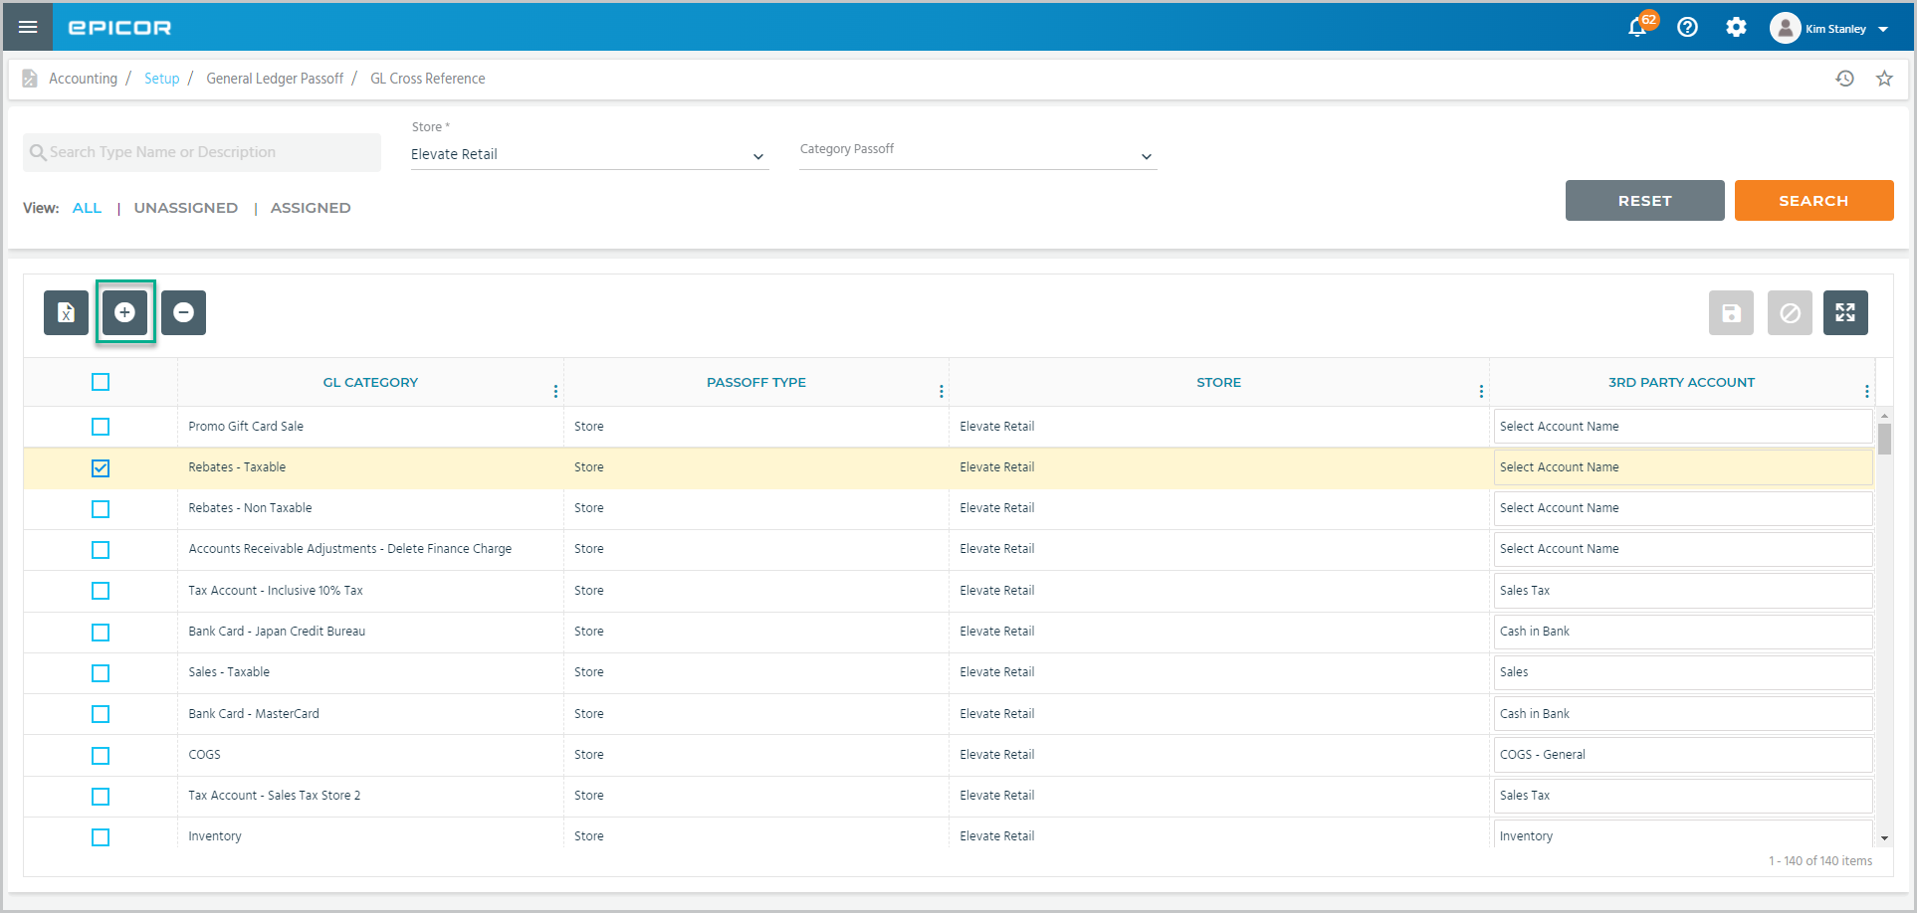  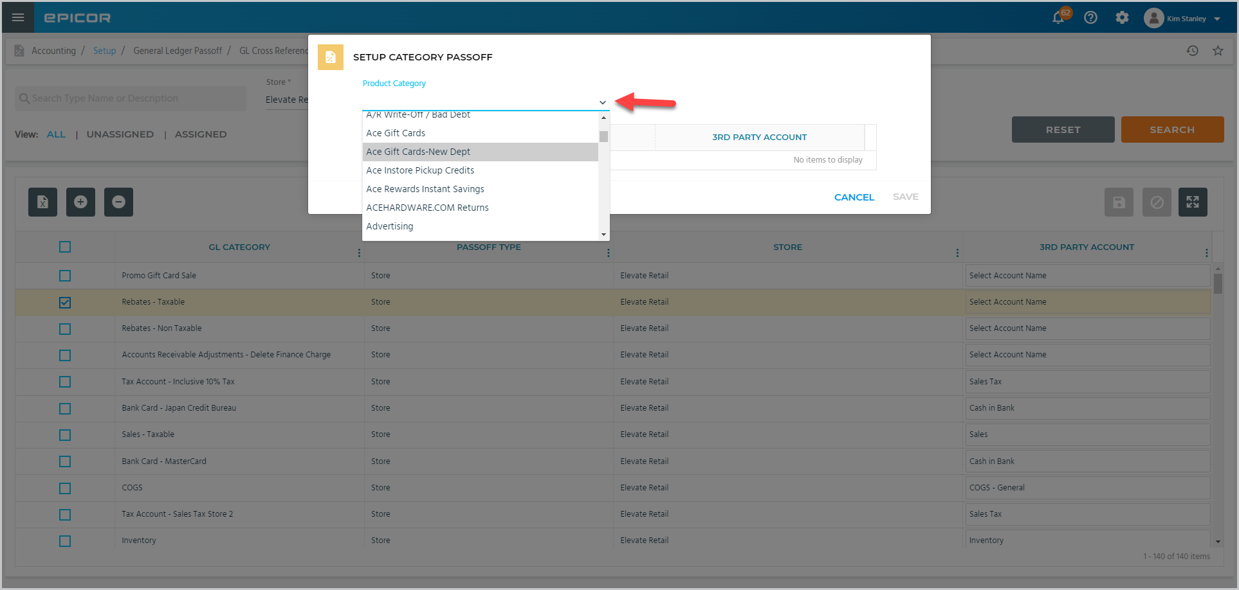  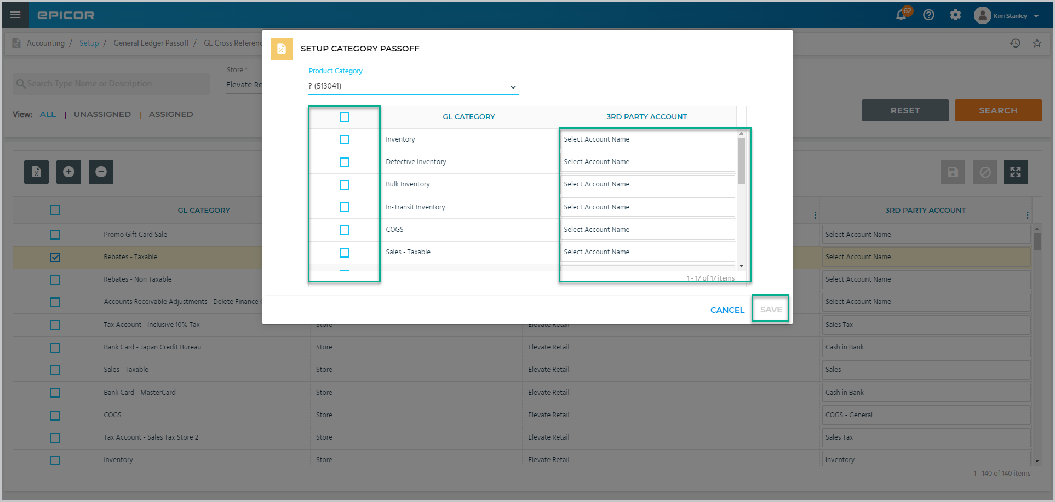
 | Click the right arrow to proceed to the next topic.

Topic B – Using the GL Transaction Viewer
 | Narration | Action/Notes
 | Use the GL Transaction Viewer to audit the GL integration or create a worksheet for manual entry into any accounting system.  From the main menu, select Accounting > GL Transaction Viewer | 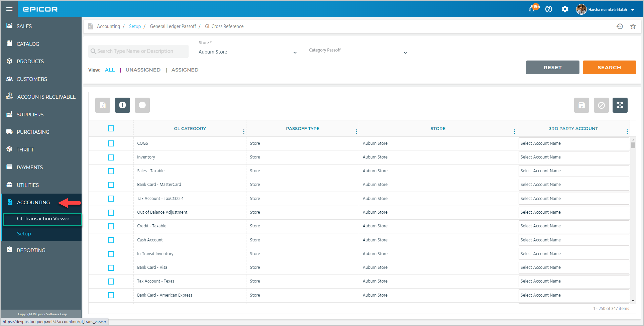
 | Use the available filters to view specific transactions.  Group by Source allows you to view the sum of debit and credit in each GL category from every source.  Select this checkbox to group your transactions based on your 3rd party GL accounts.  These checkboxes are available only after you set a date range. | 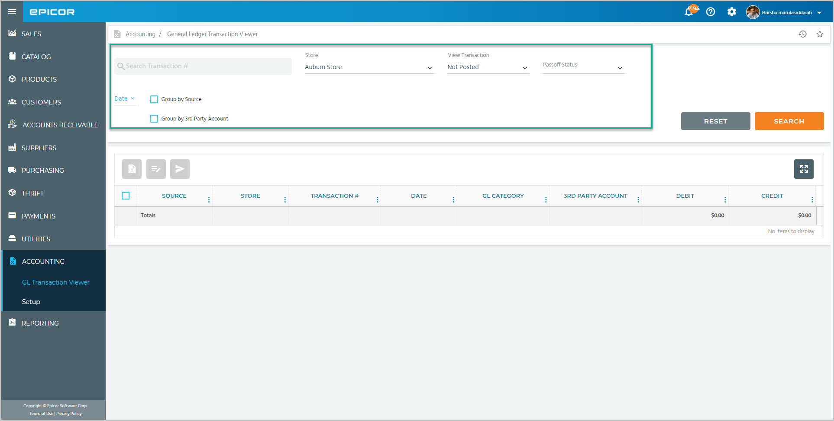  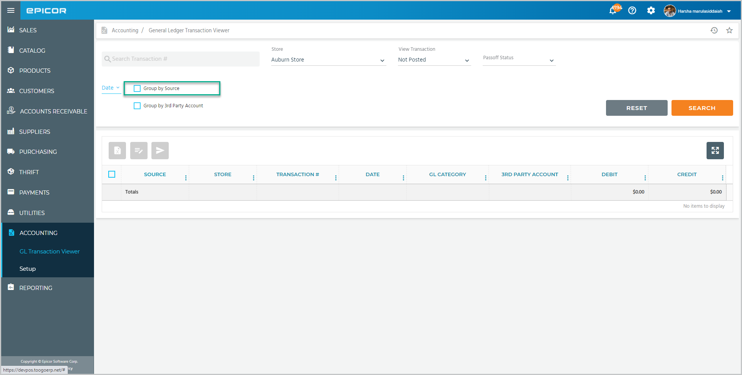  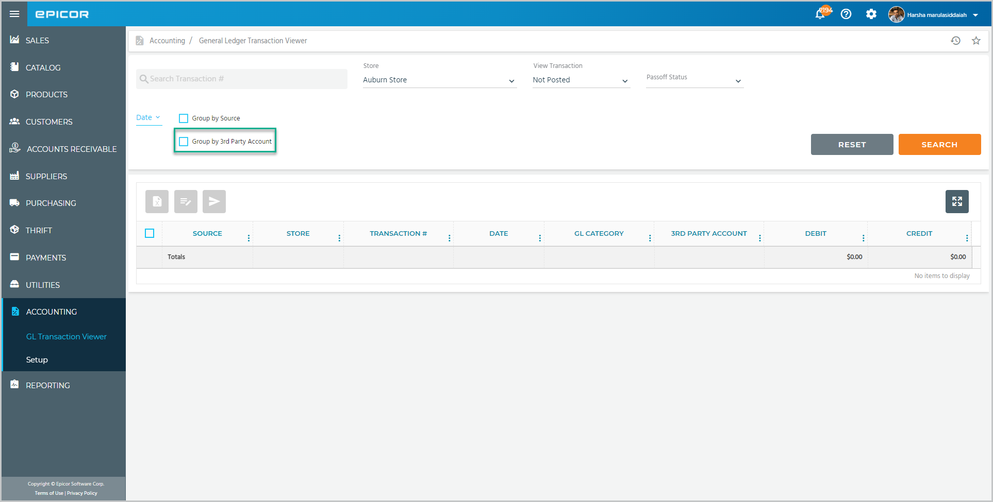  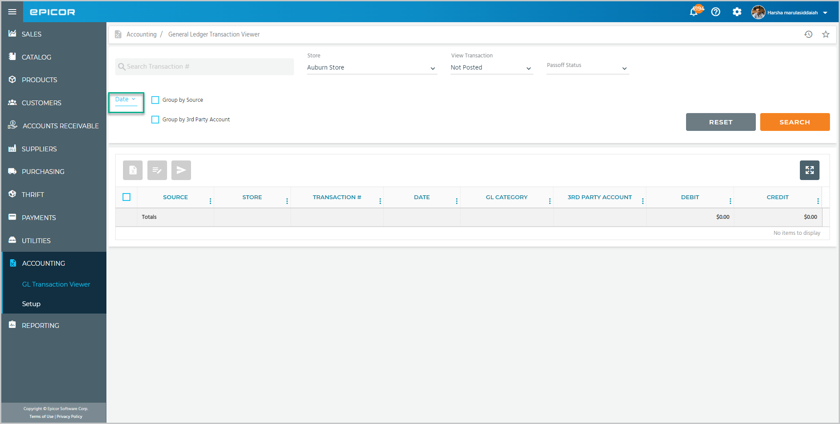
 | Tap Search to view the results.  Check the box to select a transaction or check this box to select all transactions.  Export to Excel allows you to export the data to Excel.  You can edit a transaction that needs an out of balance adjustment. | 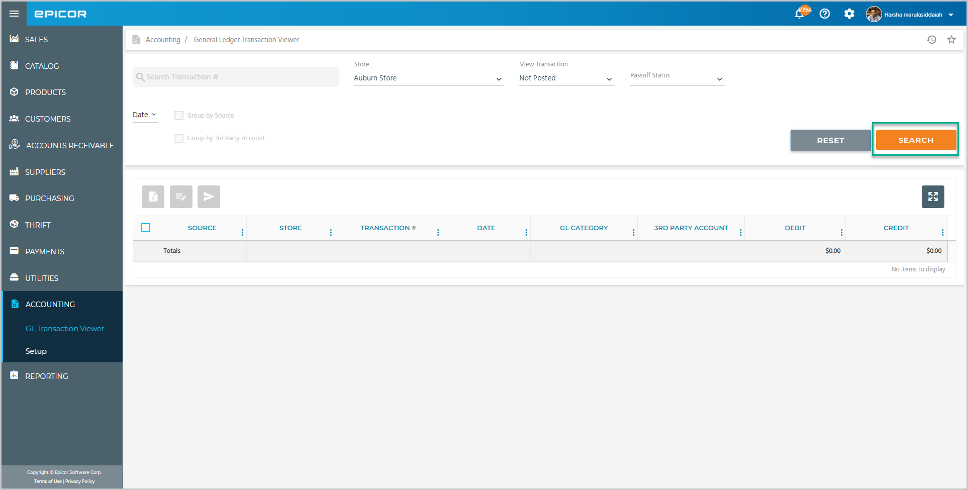  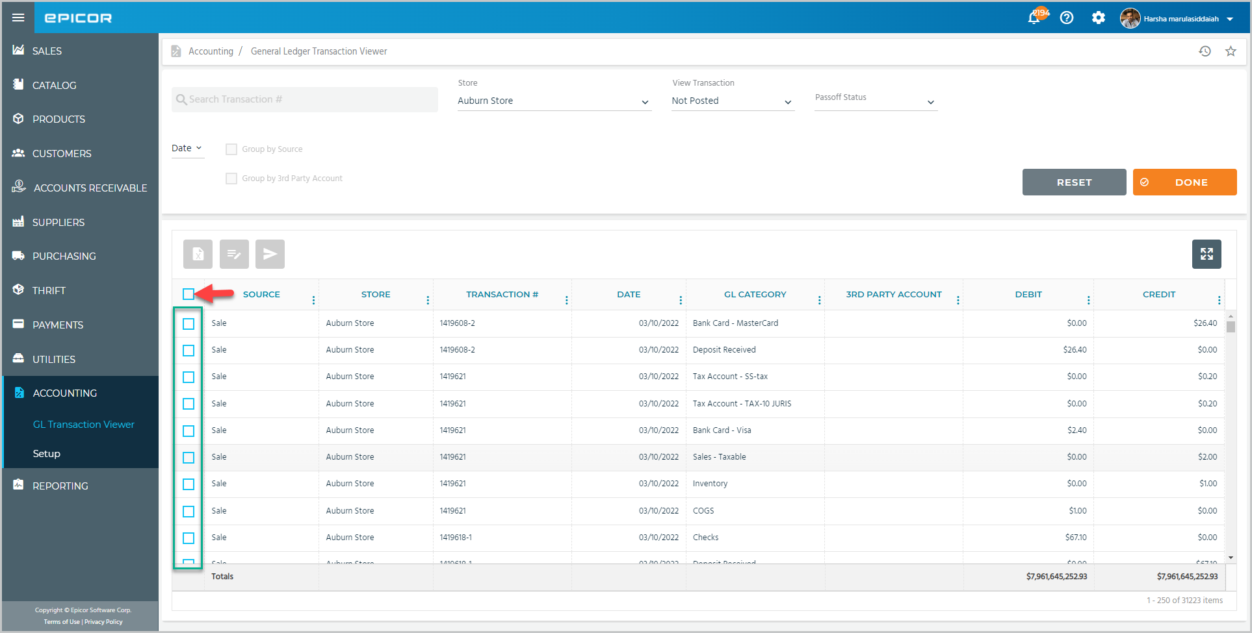  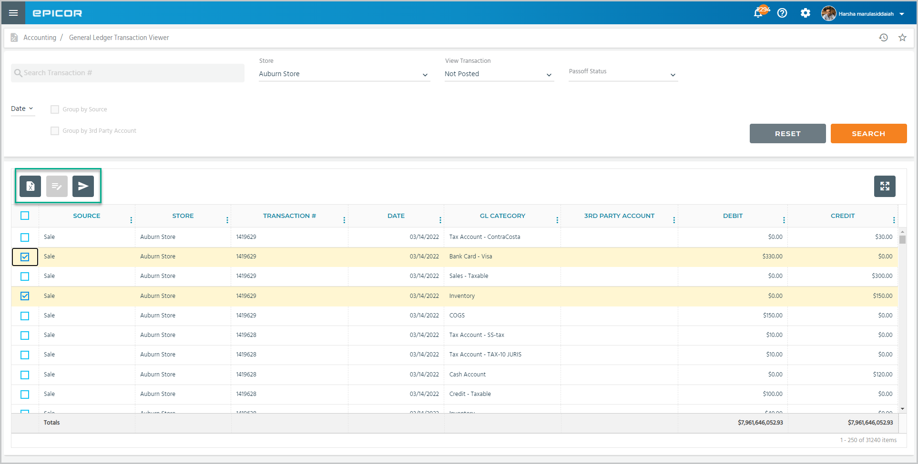
 | Note that you do not get the same totals when comparing the GL Transaction Viewer Detail to the same output with one of the Group By filters.  The data sheet displays the debit and credit net values put in either column. Without the filter, the detail output lists them separately. To check the figures, confirm that the total debit value is equal to the total credits. | 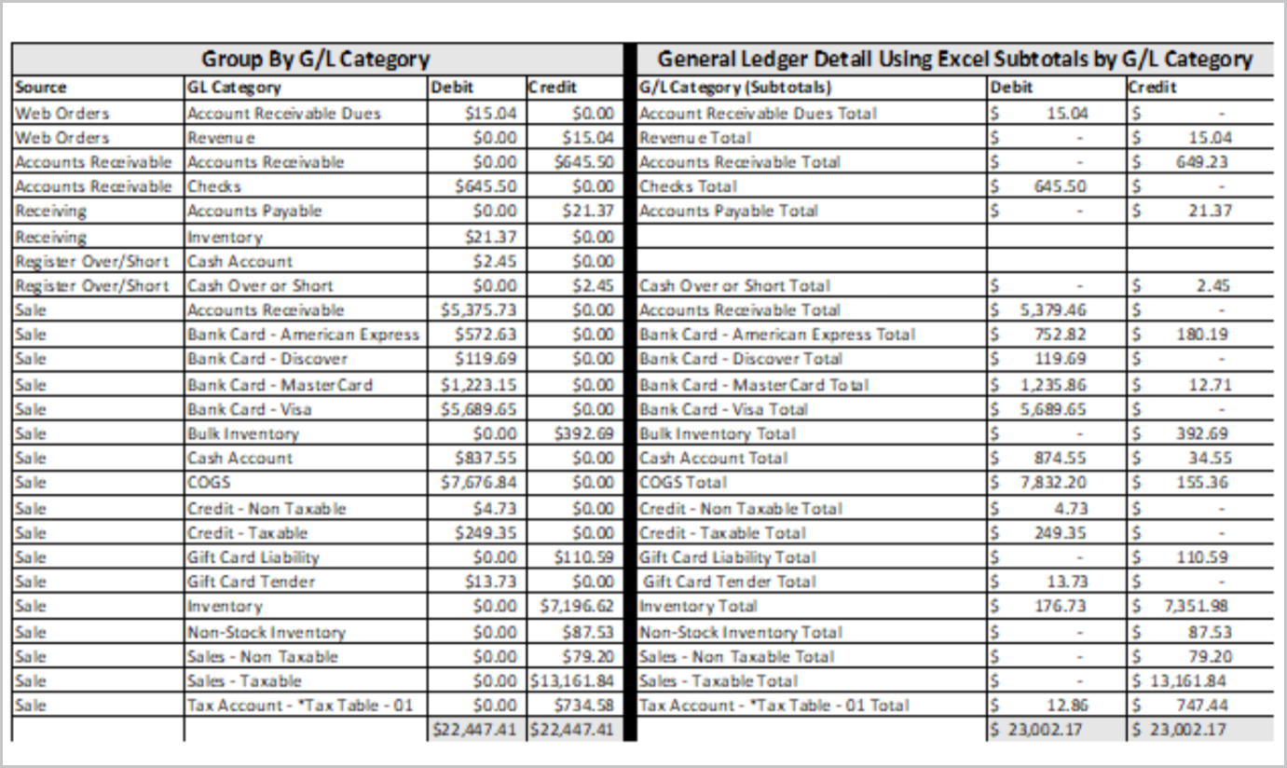

Recap
 | Narration | Action/Notes
 |  | Setting Up and Using the General Ledger Cross Reference
 | In this course, we showed how to map the Propello GL accounts to a 3rd party chart of accounts and used the GL Transaction Viewer to review the activity. | Objectives:  - Setting Up General Ledger Cross Reference  - Using the GL Transaction Viewer

