Name of Course | Setting Up and Using Estimates |  |  | EDP-26571
Writer | Anand VM | Reviewers | Kim Stanley
Software Version | 2021.3 | Date | November 26, 2021
Attendee Group |  | Roles | All
Categories | Point of Sale | Subcategories | Store Set Up
Course Description | Configure your estimation parameters so you can offer your customers project quotes.
System Screens*  *Required field in CourseTracker | Home, Estimates, POS, EDP-26571

Training snapshot (list the topics to illustrate the topics in the course)
 | Introduction | Name of Topic | Knowledge Check Yes/No
 | Topic A | Setting Up Estimates
 | Topic B | Creating Estimates
 | Topic C | Recalling & Repricing Estimates
 | Recap

Introduction
 | Narration | Action/Notes
 | Everyone likes to plan ahead and get an idea of how much something might cost them.  Estimates help your customers evaluate the cost of a project and they give you the ability to offer specific retail pricing. | Setting Up and Using Special Orders
 | To get started, we will examine the various estimation parameters and the available options.  Then, we will create an estimate in point of sale and transition that to an order when the customer determines to move forward with the purchase.  We will also recall and reprice an estimate.  Choose a topic to learn more. | Objectives:  - Setting Up Estimates    - Creating Estimates    - Recalling & Repricing Estimates  

Topic A – Setting Up Estimates
 | Narration | Action/Notes
 | Before creating an actual estimate, we need to configure some estimate parameters.  From the main menu, select Sales, Setup and then Estimate.  Keep in mind that these settings are applied across companies and not specific stores. | 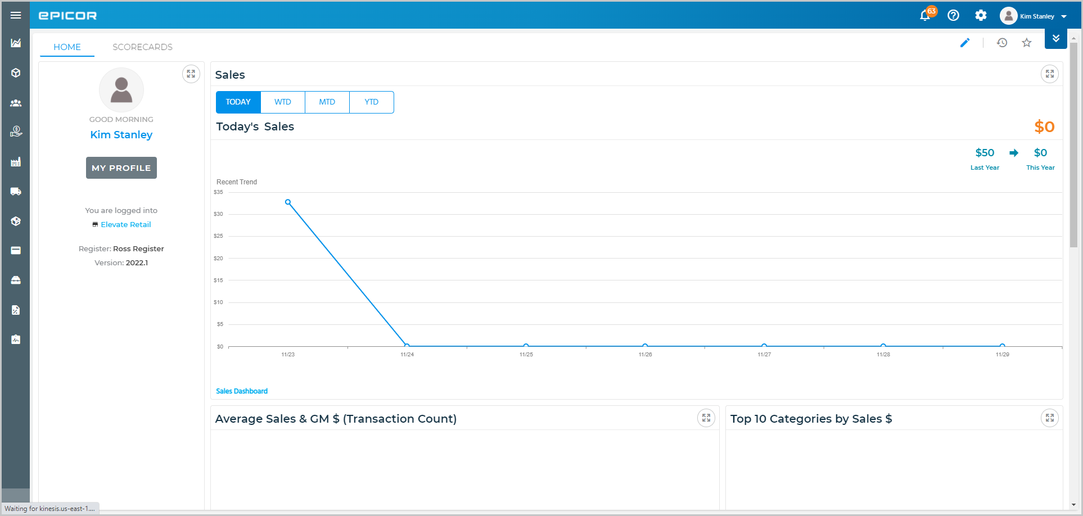  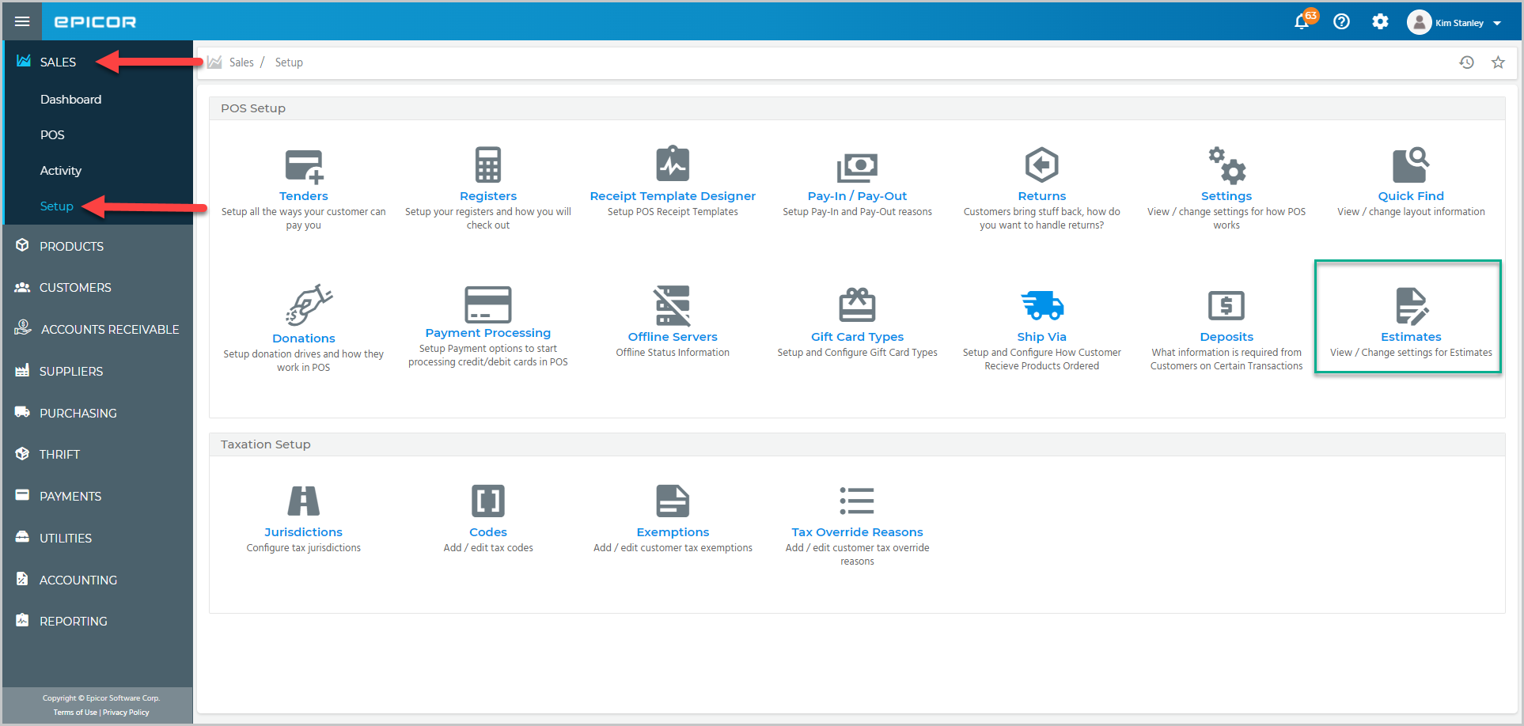  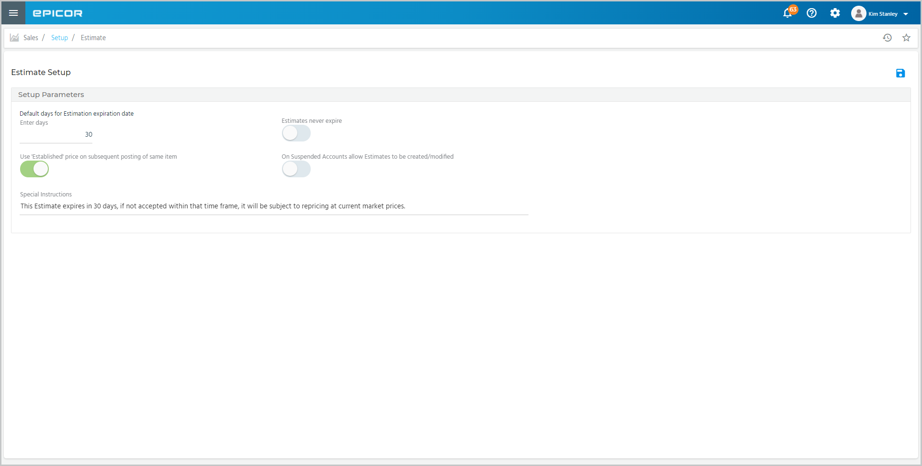
 | Enter the number of days the estimate is valid from the creation date in the Default days for Estimation expiration date. You can enter a value between 1 and 999.  Switch this toggle on if estimates do not expire.  To retain the last retail price manually entered for an item, switch the Use “Established” price on subsequent posting of same item toggle on. | 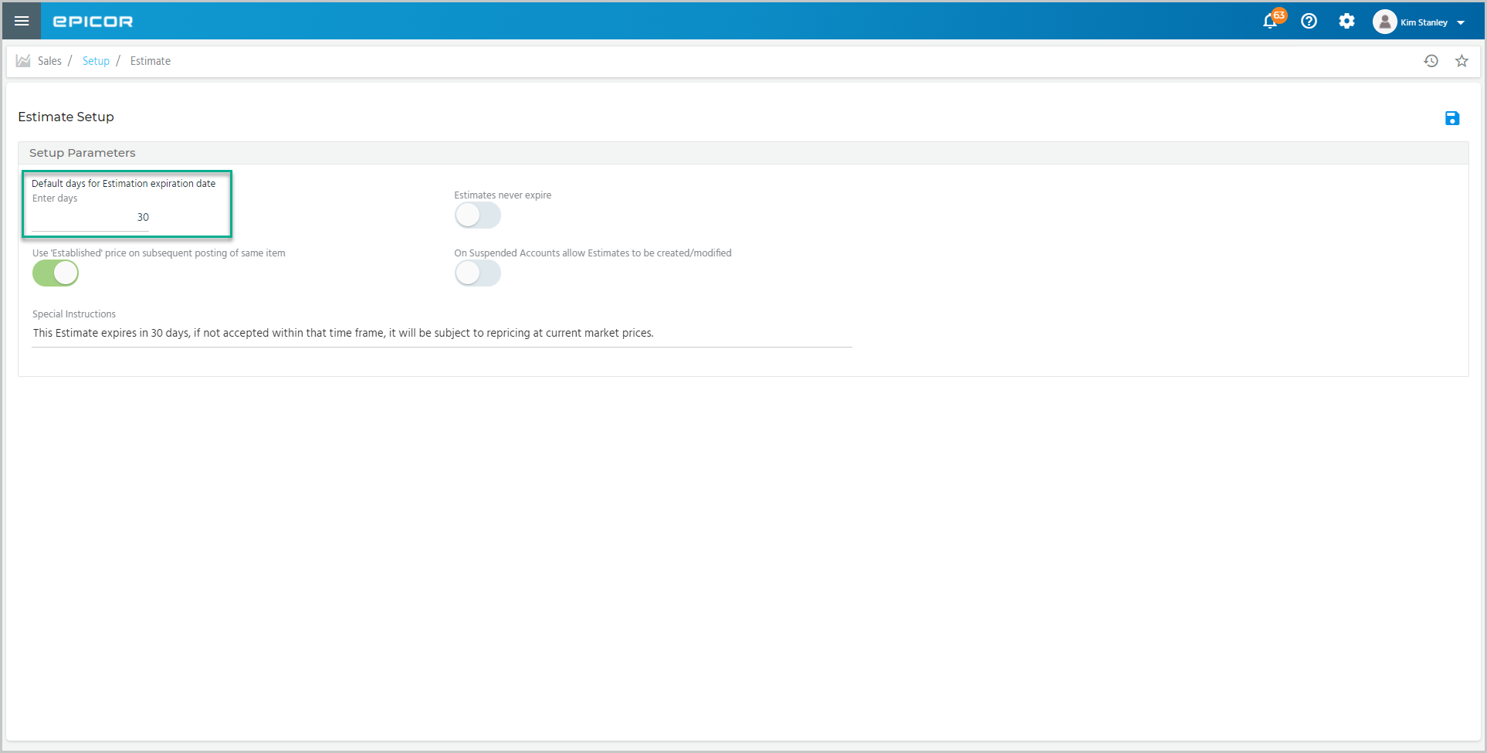  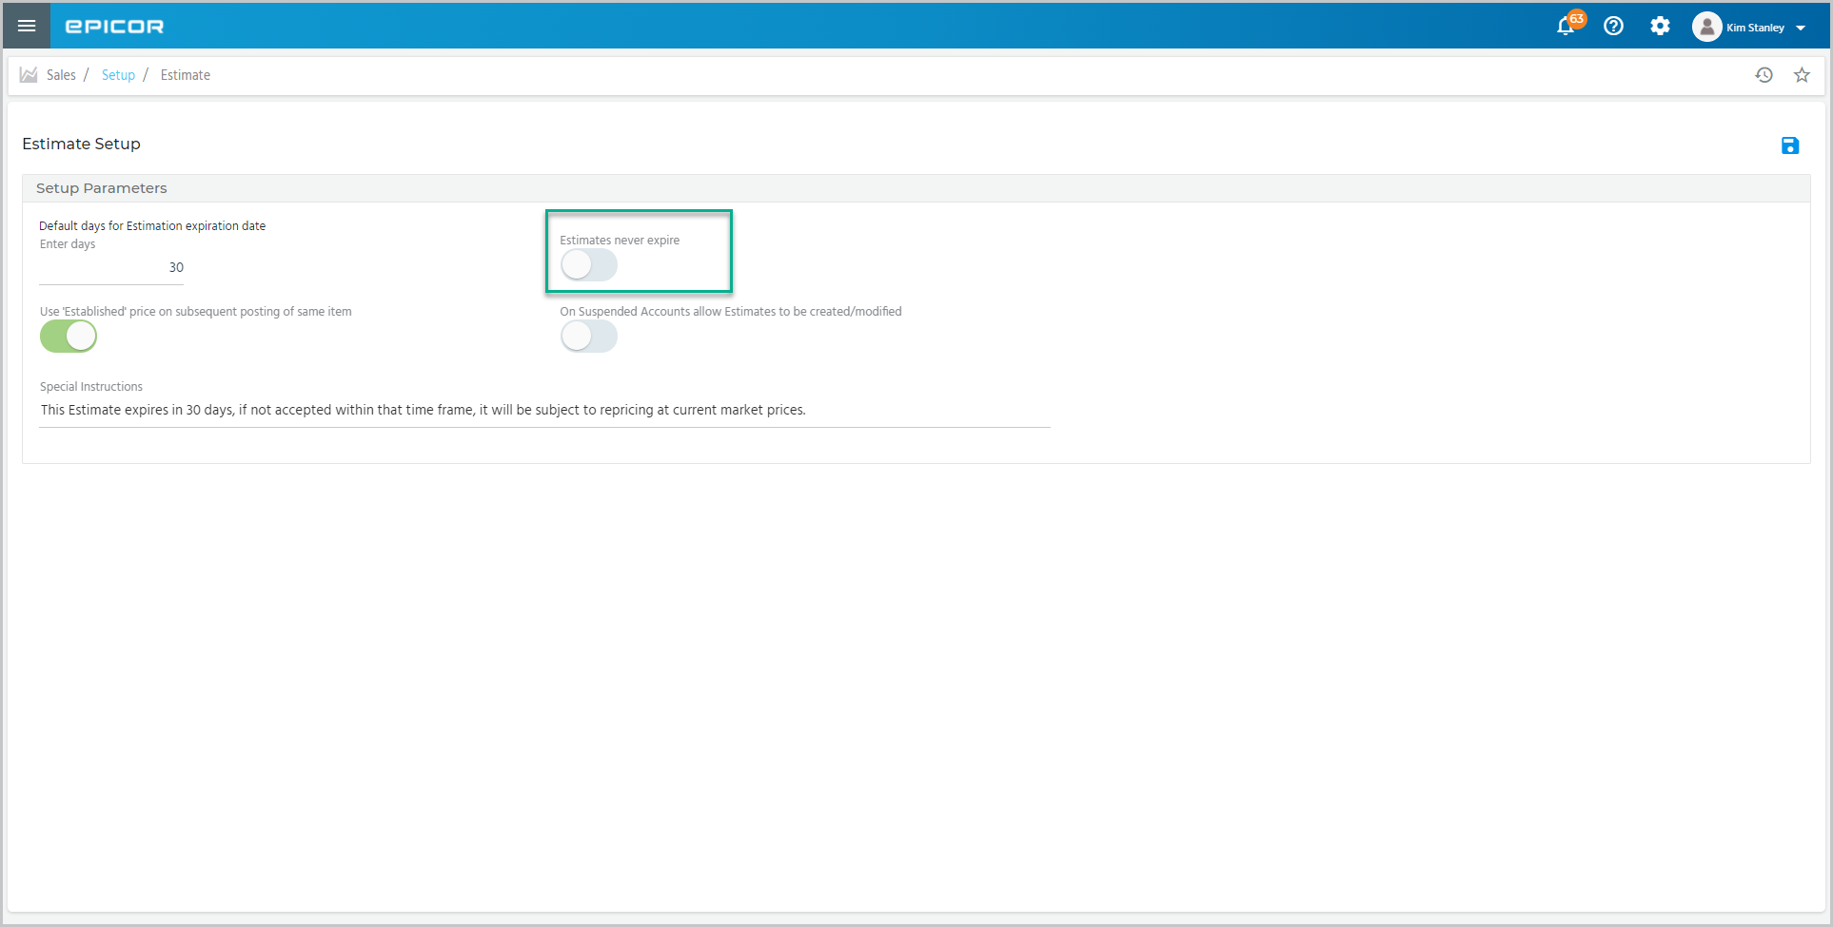  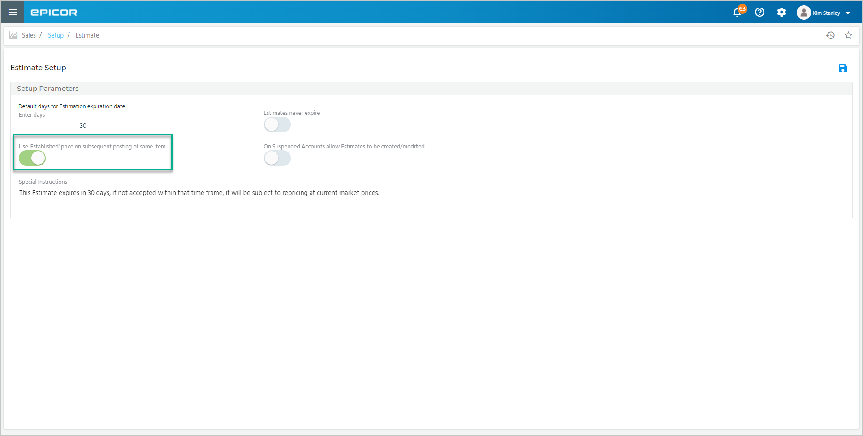
 | Switch this toggle on if you permit suspended customer accounts to receive an estimate.  Enter any instructions to be added to the estimate in this field. These instructions appear on the footer of every estimate. The text is limited to 150 alphanumeric characters.  Press Save to update the changes. | 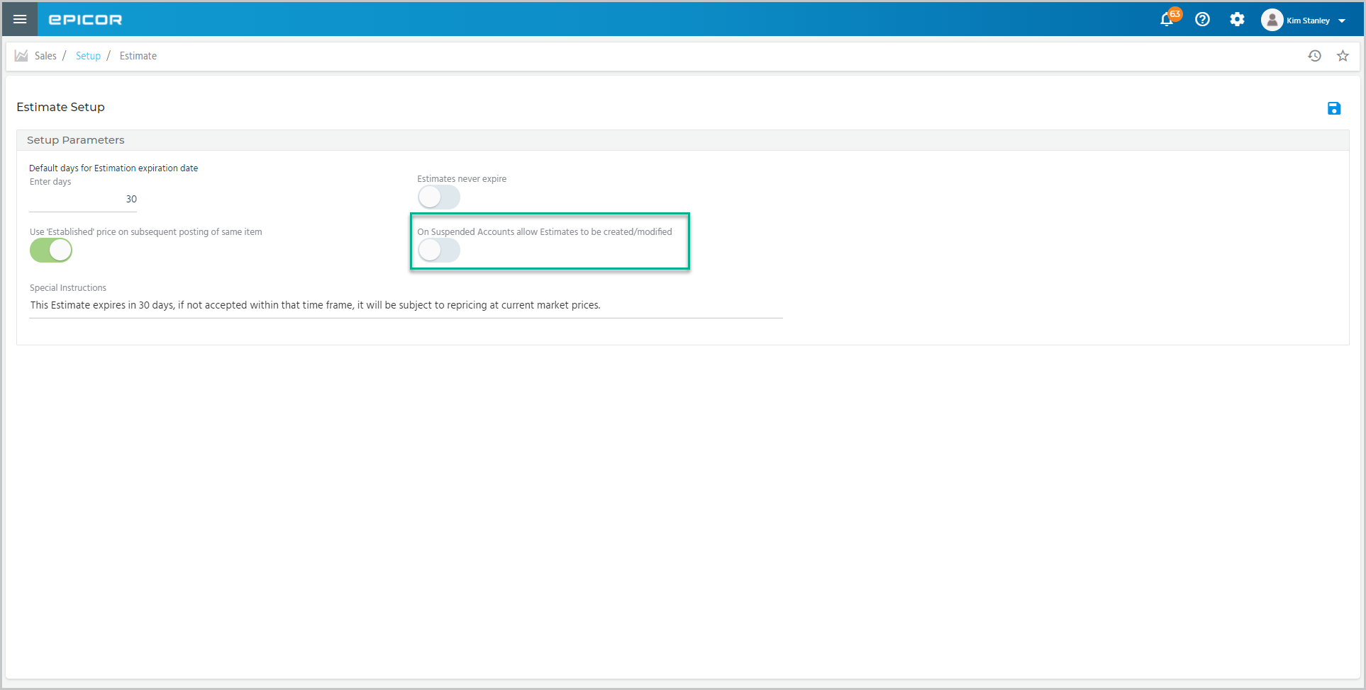  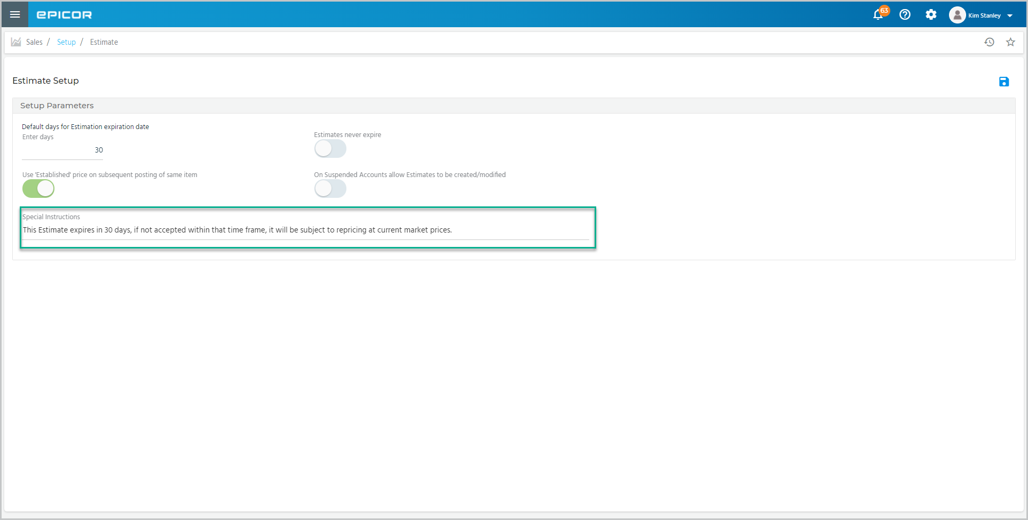
 | Select the right arrow to proceed to the next topic.

Topic B – Creating Estimates
 | Narration | Action/Notes
 | Once the parameters are setup, you can create an estimate in point of sale.  Select Estimate from this drop-down.  Locate a customer account using the search field. | 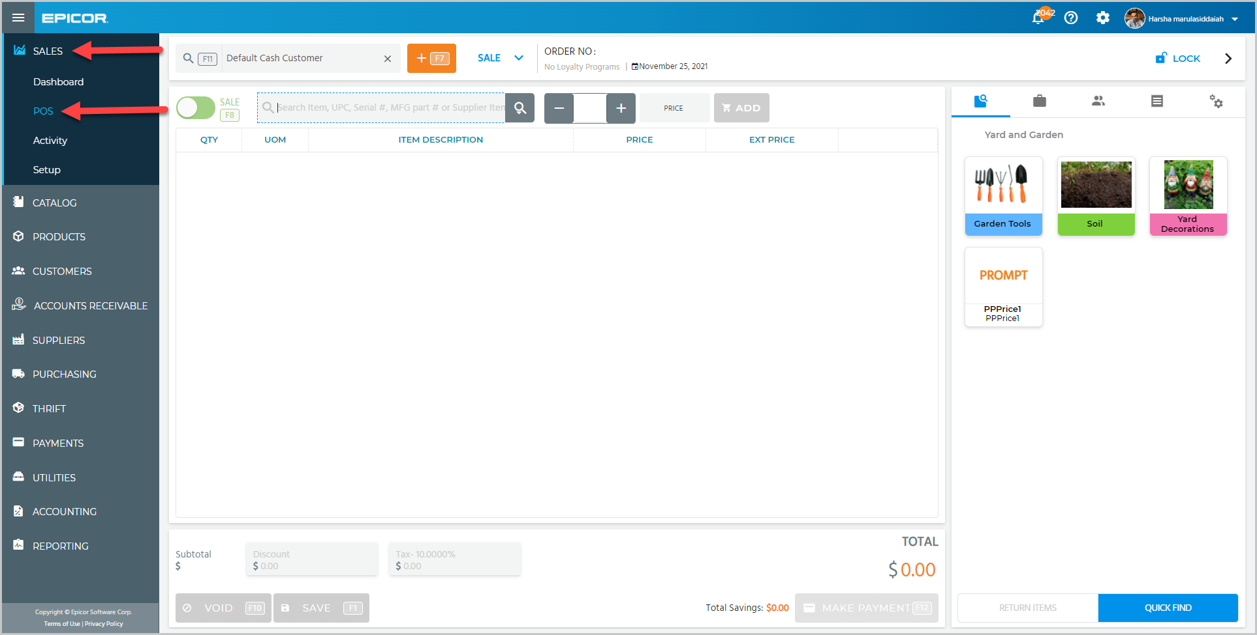  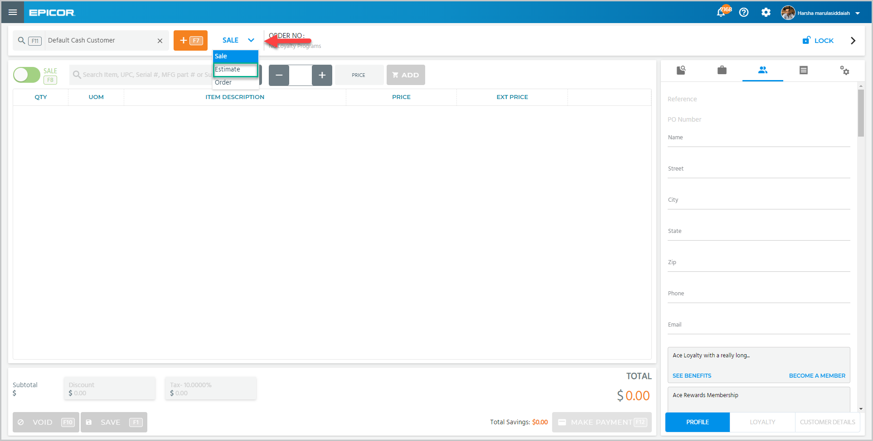  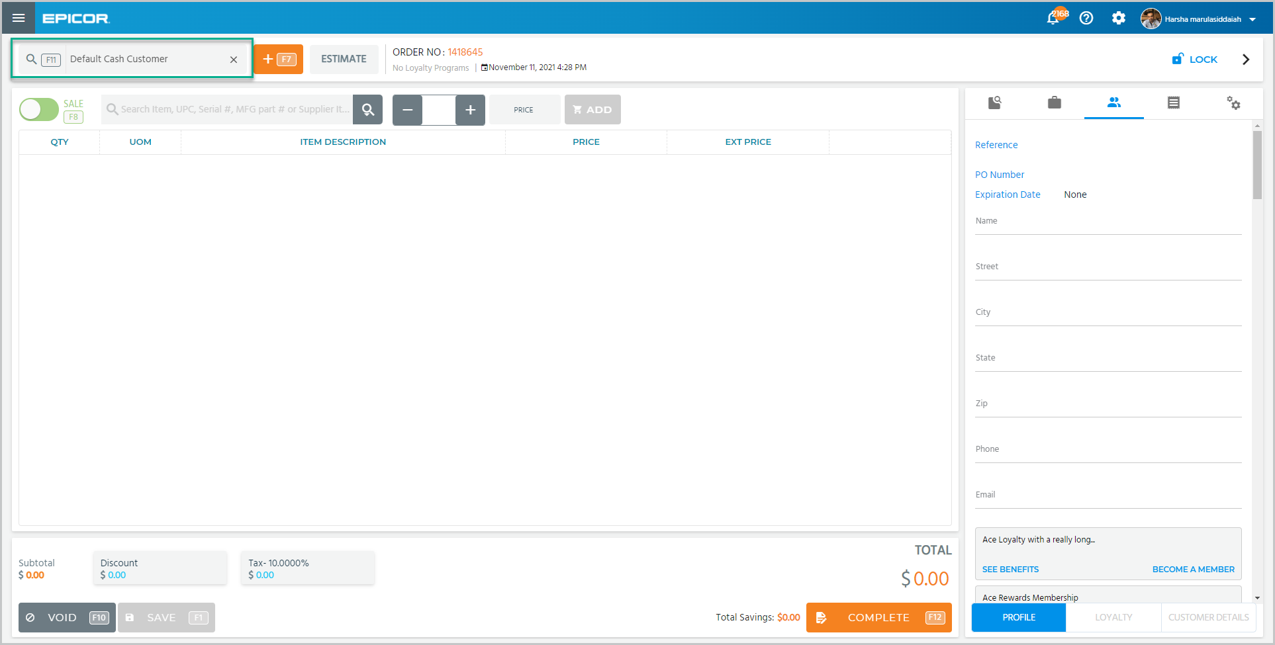
 | Let’s create an estimate for a customer who wants to build a wooden deck.  Find the items and add the quantity.  Since the customer is buying so many, we may want to offer a discount to encourage the sale.  Tap Discount.  And enter the percent or the dollar amount, then tap Apply.  The Save button allows you to save the estimate and update it later if needed.  Tap Complete to continue with the estimate. | 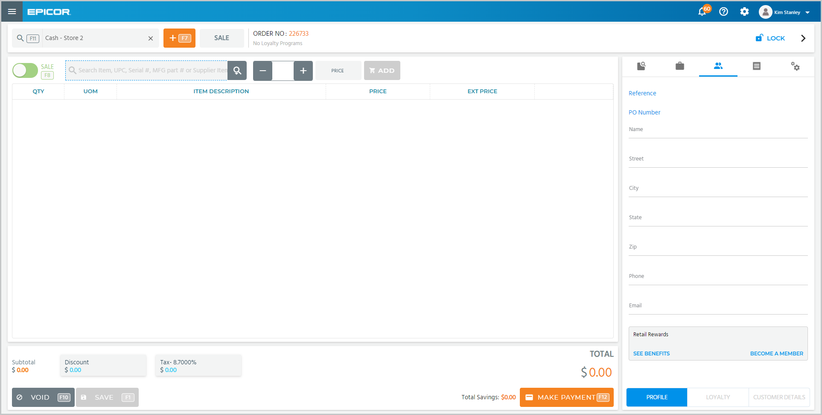  Make sure skus are set up for deck components and qty is realistic  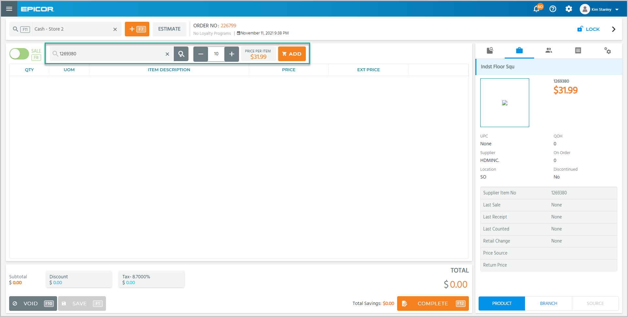  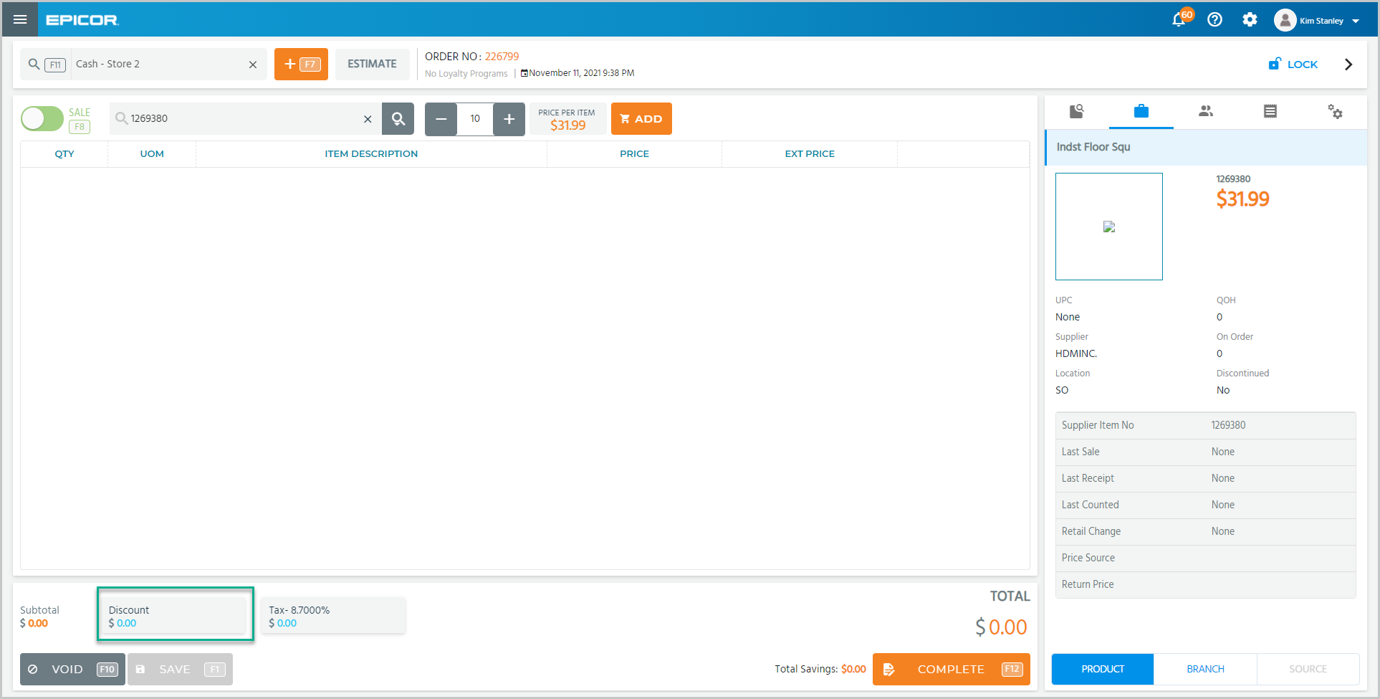  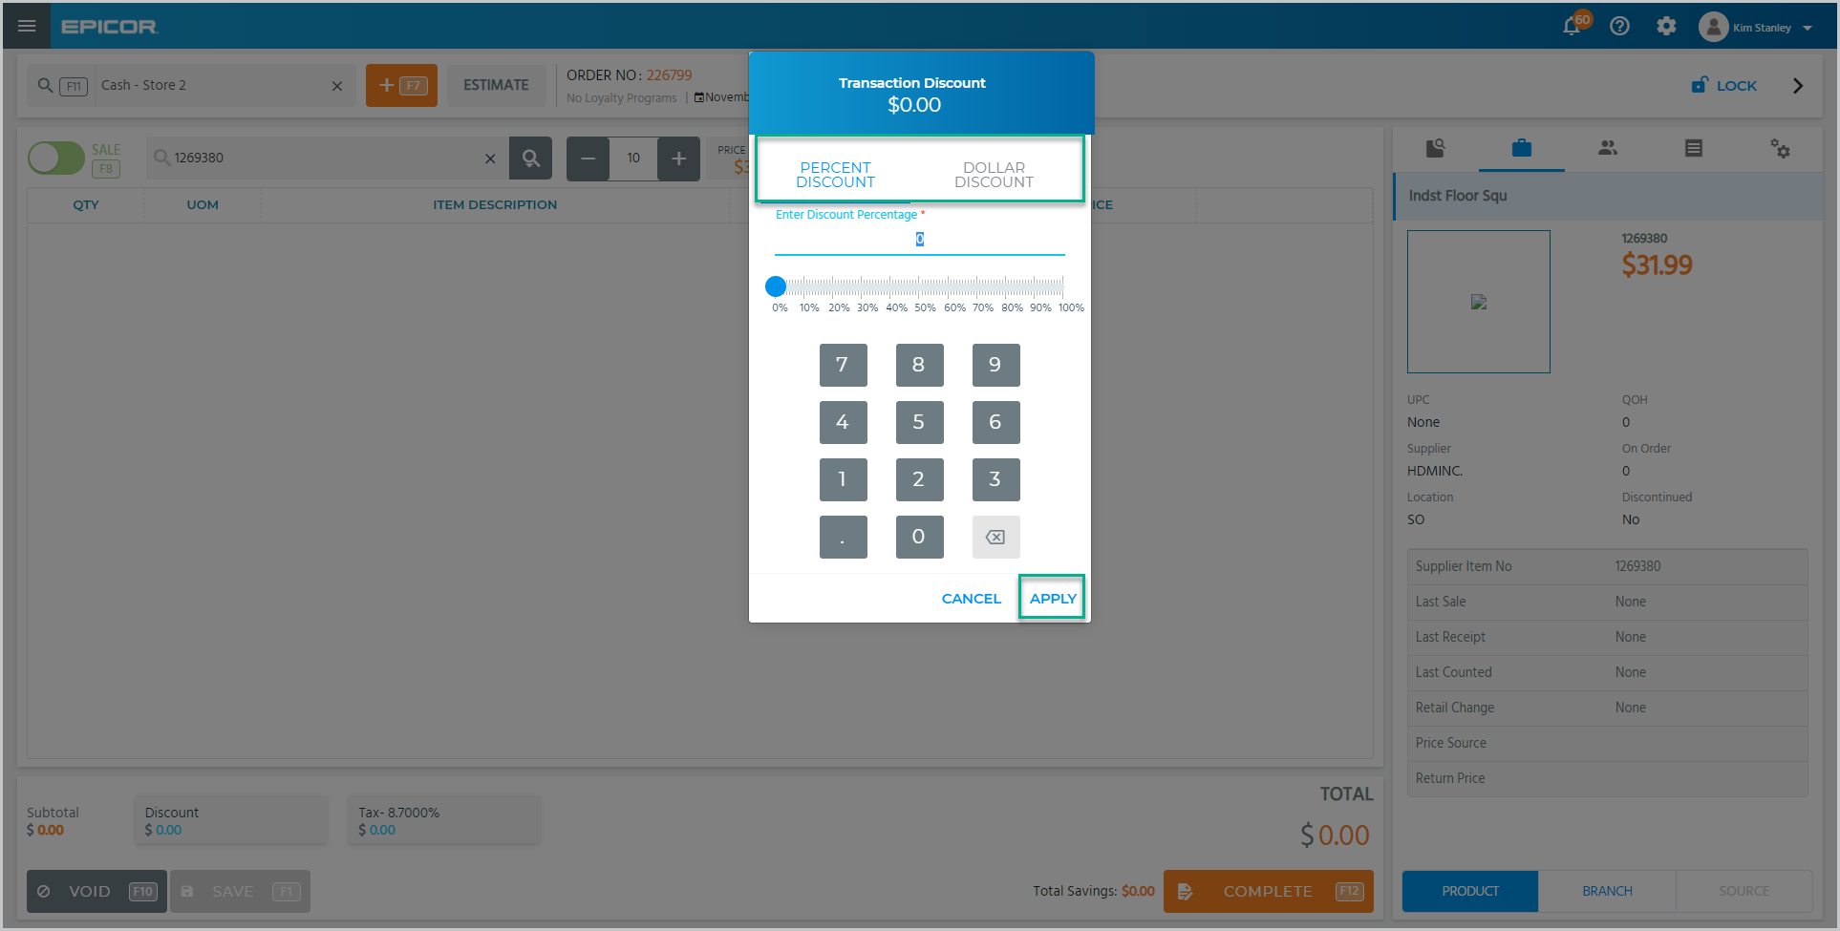  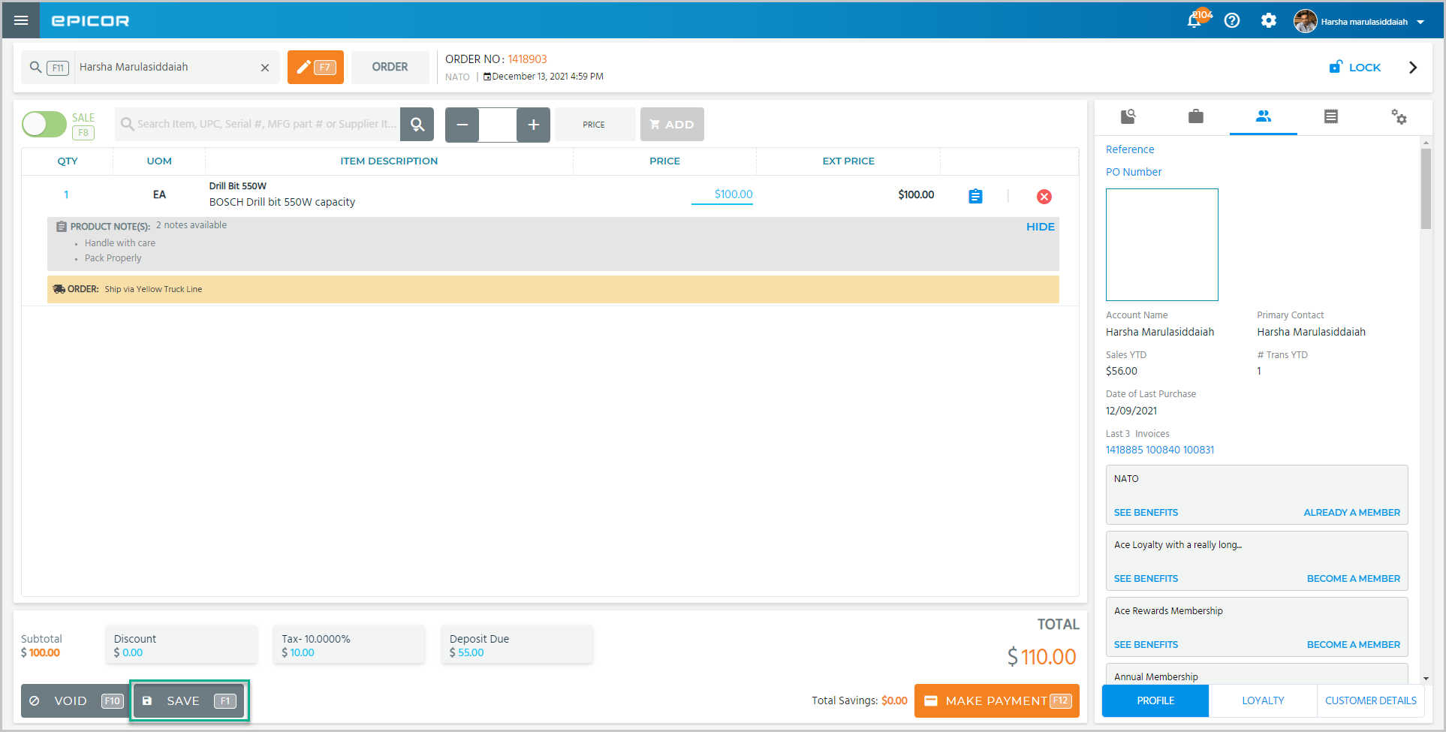  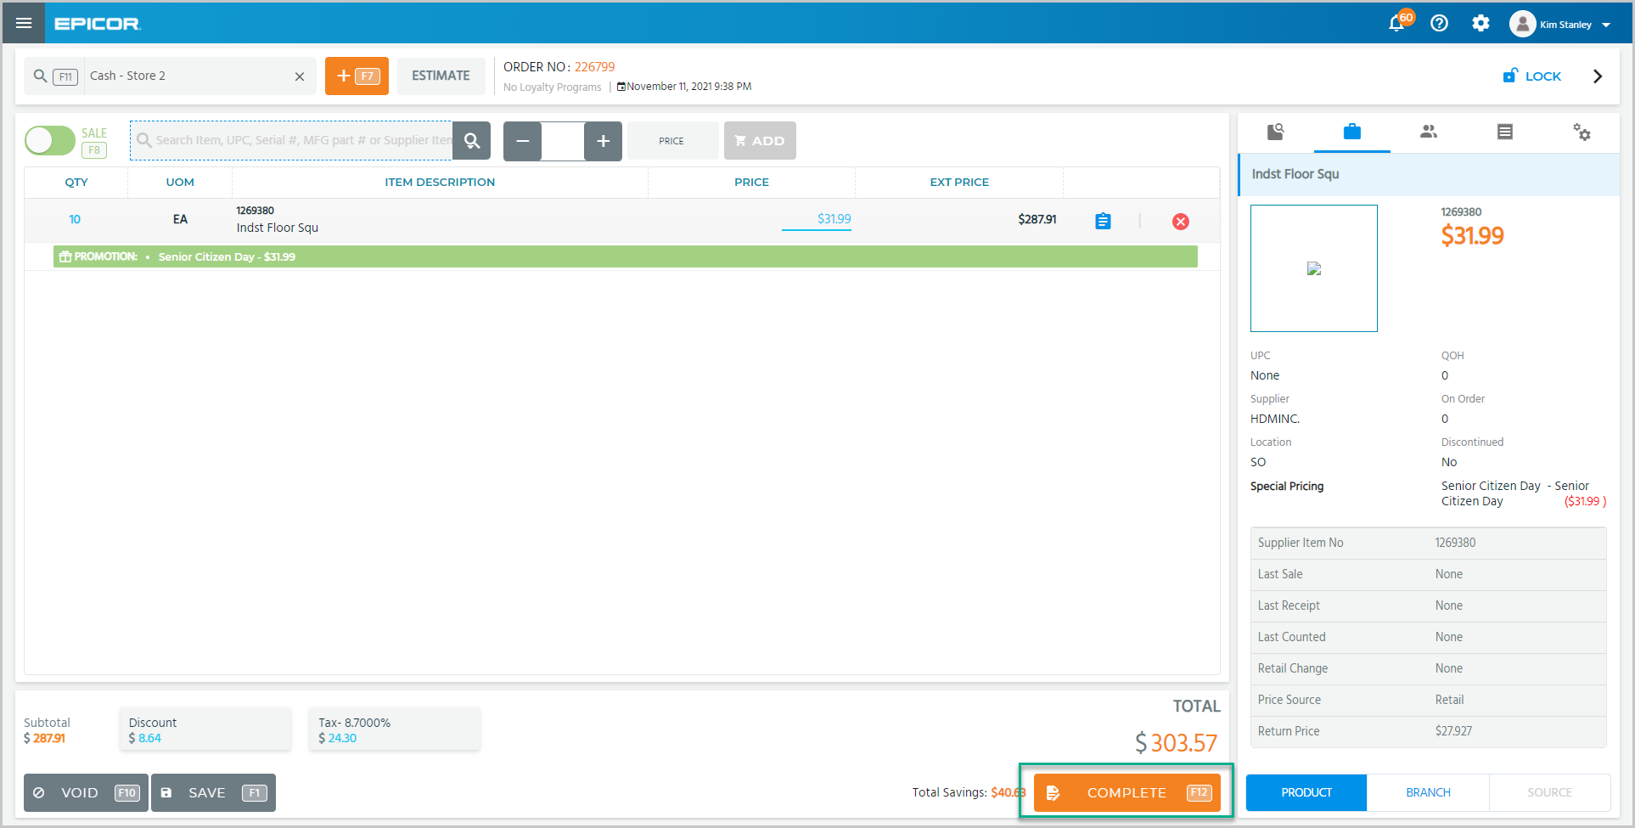
 | If a customer is not selected while creating the estimate, you will need to create a new customer.  Tap Yes if the customer agrees to the terms and conditions.  Fill in the required information and tap Add Customer. | 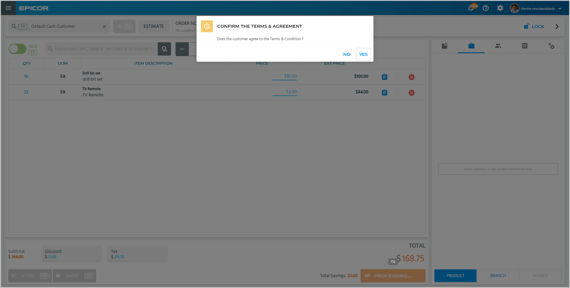  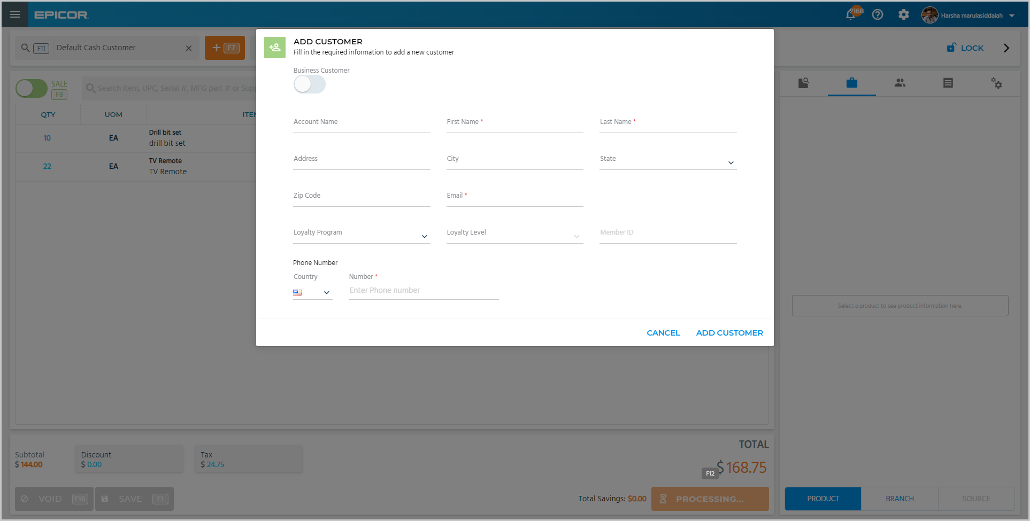
 | Turn these toggles off if you do not want to print the price or quantities on the receipt.  You can easily change this estimate to a sale or an order with these options. | 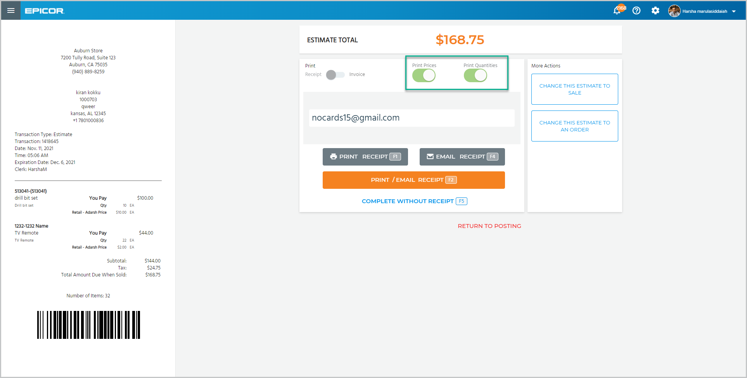  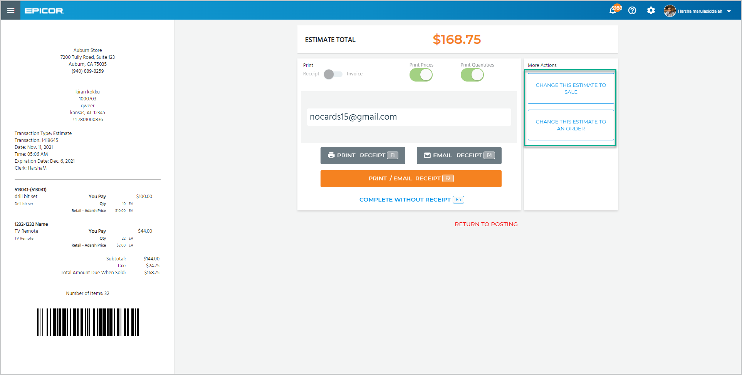
 | After seeing the final amount, the customer has decided to go ahead and order the items.  Tap Change This Estimate To An Order.  Tap Yes in the confirmation pop-up.  Update the item’s sourcing information in this page.  Select the items using the checkboxes and tap Edit.  Choose the items’ source from this drop-down and select the shipping method from here.  Tap Save.  Tap Close to return to the posting screen. | 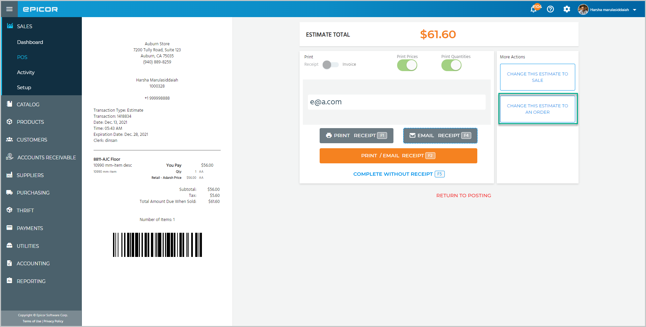  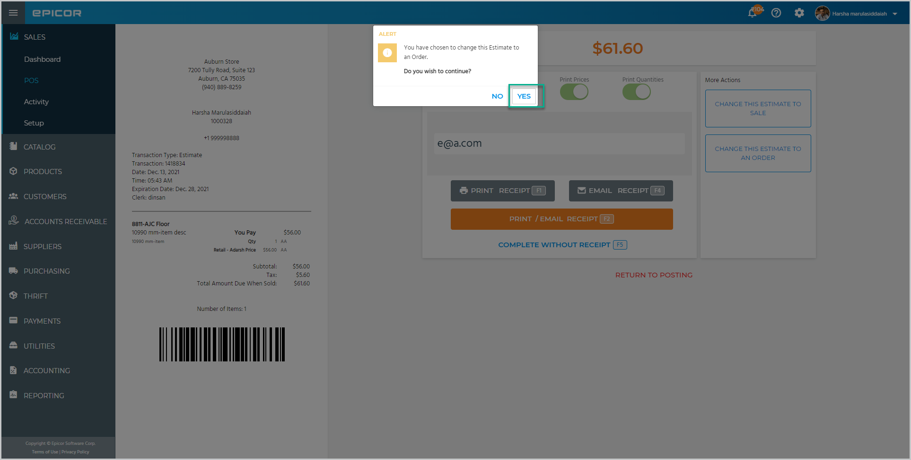  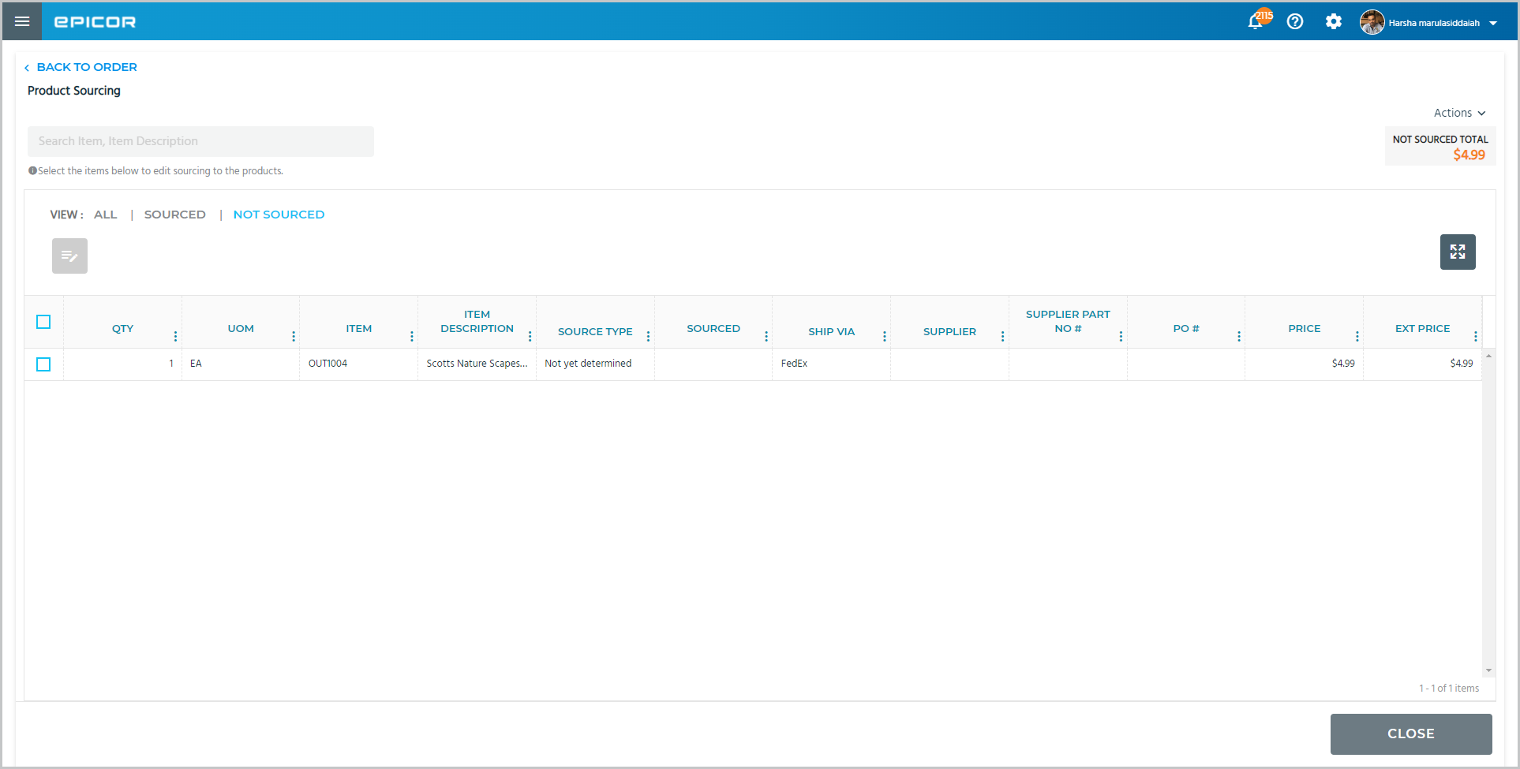  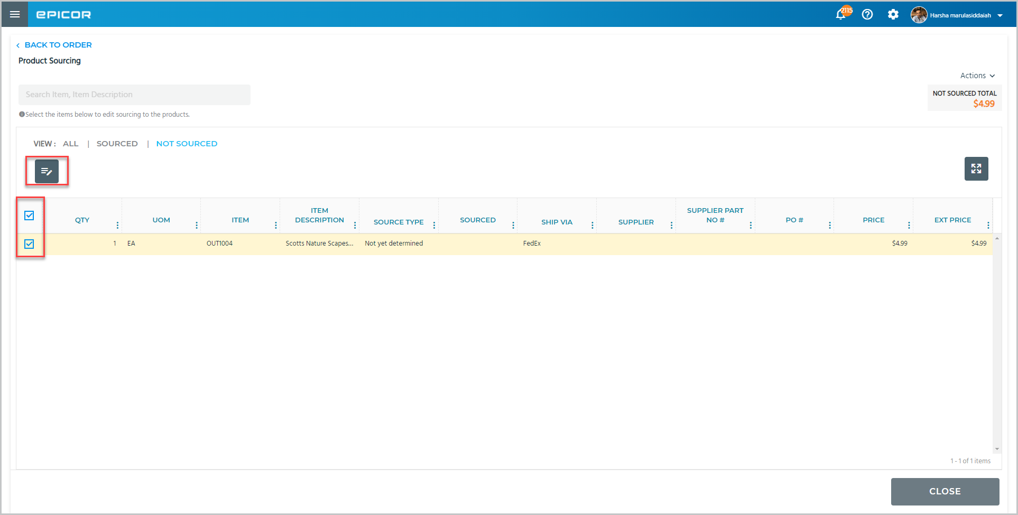  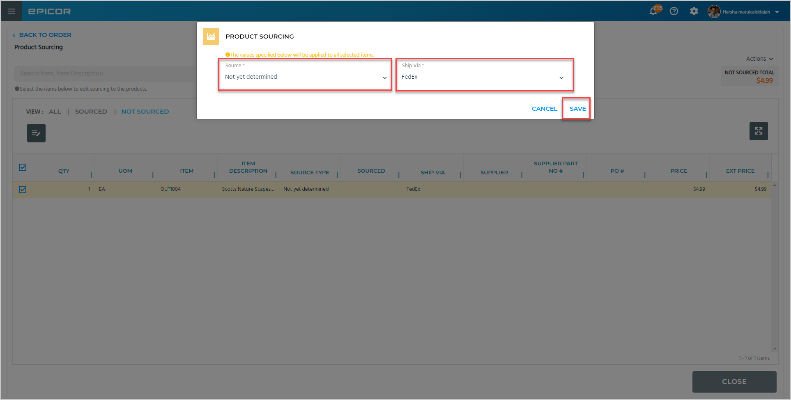
 | You can see the created estimate is now an order.  Tap Make Payment to continue with the transaction. | 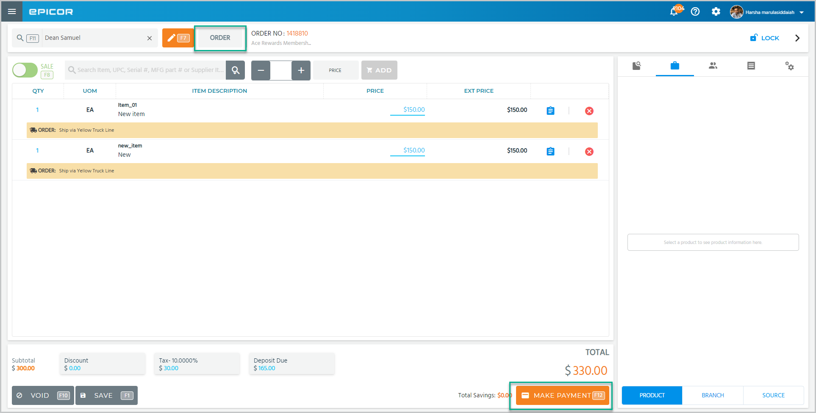
 | Select the right arrow to proceed to the next topic.

Topic C – Recalling and Repricing Estimates
 | Narration | Action/Notes
1. | If changes to an estimate are needed, you can easily recall it in POS.  Use the search field to locate the customer. | 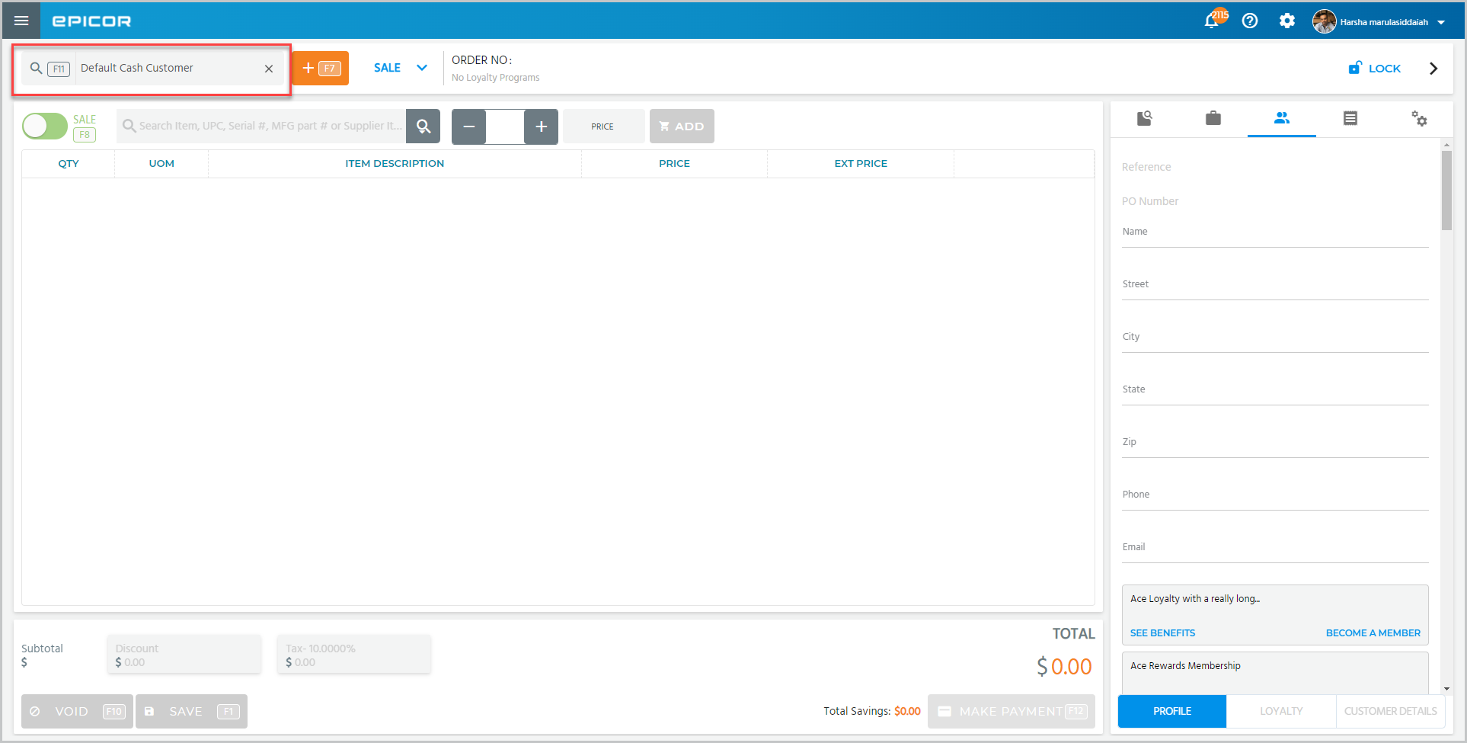
2. | Select the estimate that you want to recall using the checkbox in the Open Transactions popup and tap Post Selected. | 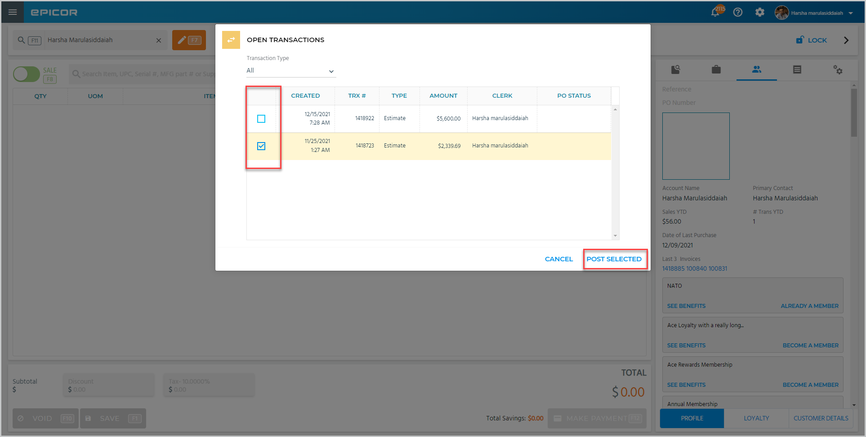
3. | It has been a few months since this estimate for a swing set was created and the price of lumber has changed.  Tap the Gear icon and select Reprice Transaction.  Determine how you want to reprice the estimate from this drop-down menu.  You can reprice to the current retail, increase or decrease by a percentage or use a new gross profit figure.  Let’s increase each item by 10% for this estimate.  Check this box to select all items and enter 10 in the Increase % field.  Tap Calculate New Prices.  You can view the old and new total here. Tap Save. | 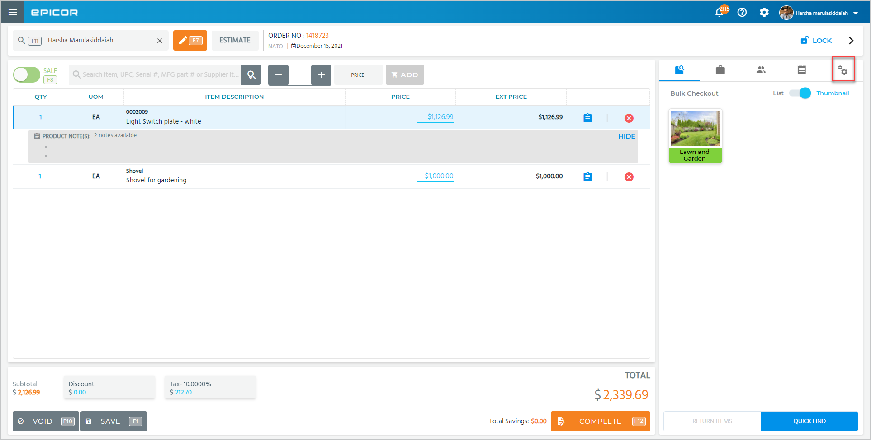  Create an estimate for a swingset – lumber, chains, bolts, swings  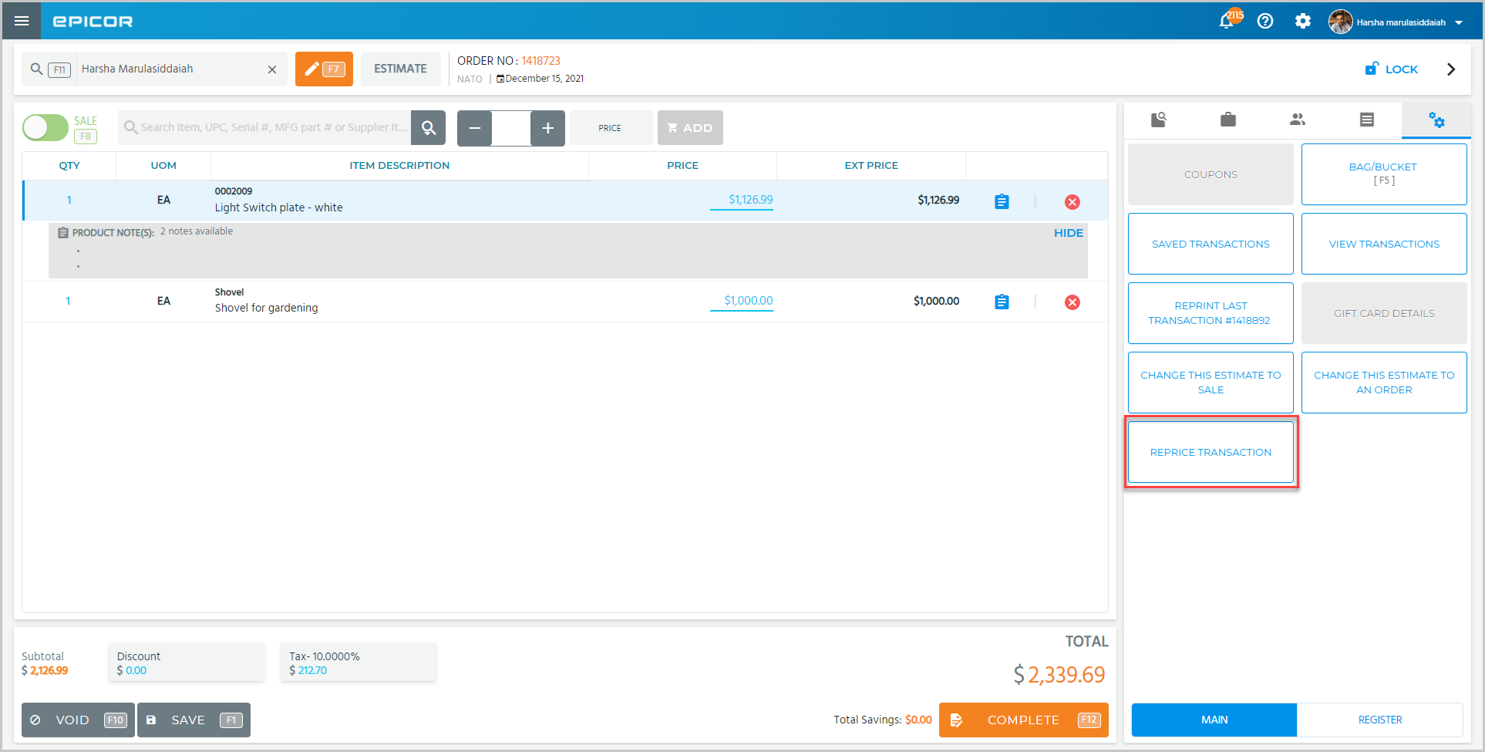  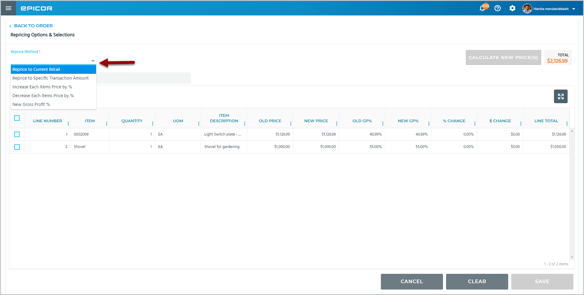  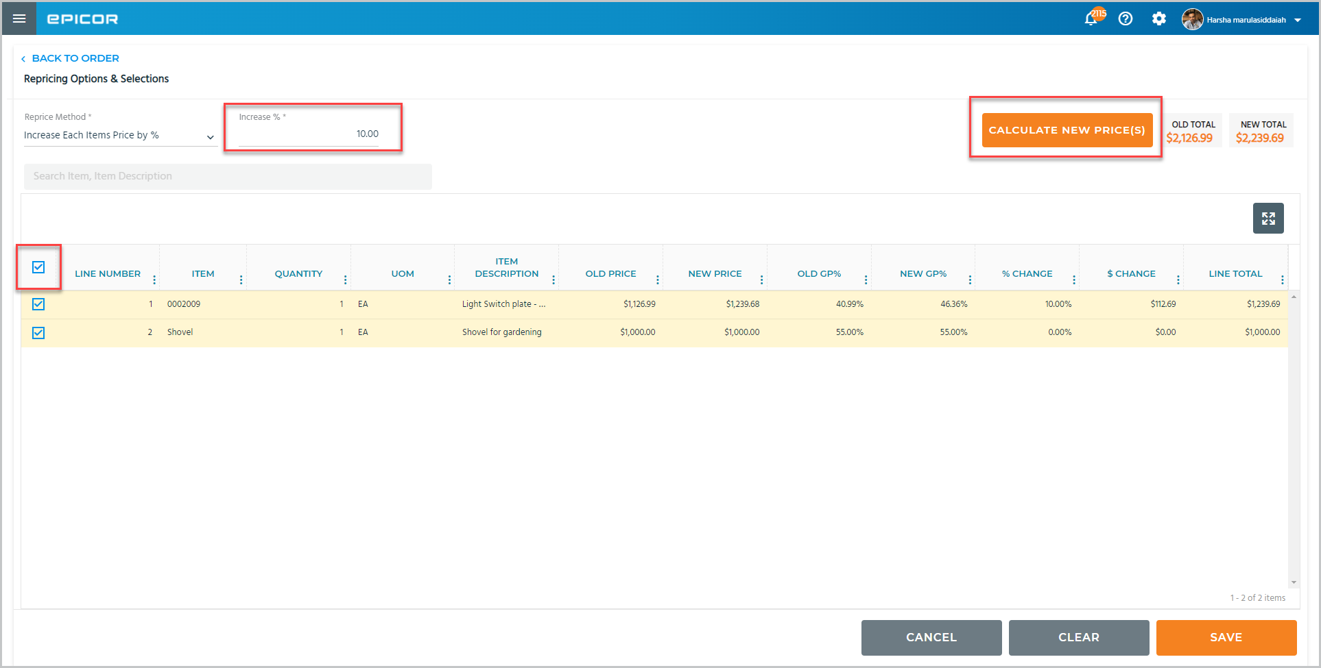  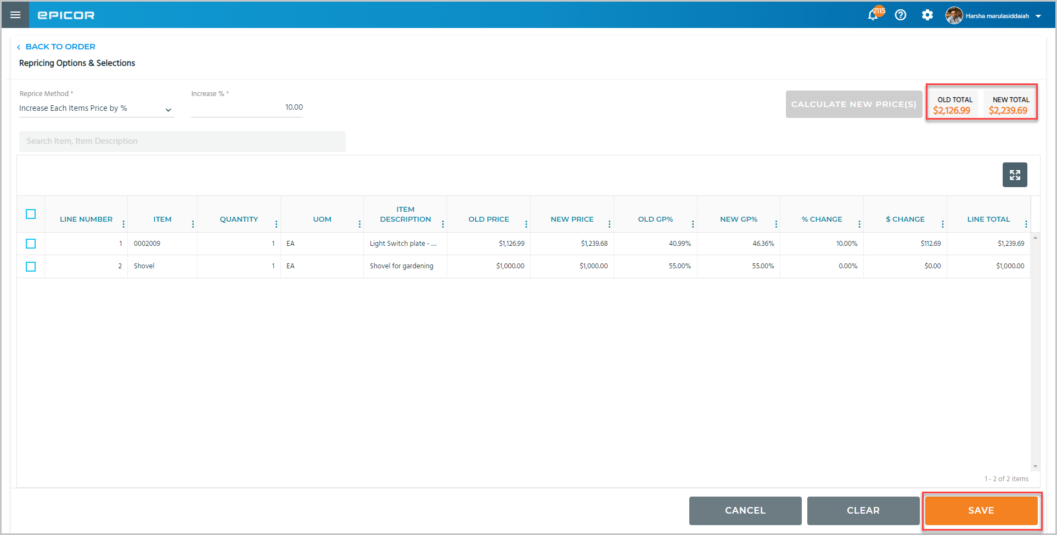
4. | Select the right icon to view the recap.

Recap
 | Narration | Action/Notes
 | Configure your parameters to follow your business procedures and then create an estimate in point of sale to give your customer an idea of what a project will cost. | Setting Up and Using Estimates
 | In this course, we showed estimation setup, created an estimate for a customer, and then converted that estimate to an order.  We also recalled and repriced an estimate. | Objectives:  - Setting Up Estimates  - Creating Estimates  - Recalling & Repricing Estimates

