Name of Course | Setting Up Companies, Stores, and Regions |  |  | EDP-25510
Writer | Robert | Reviewers | Kim
Software Version | 2021.3 | Date | September 23, 2021
Attendee Group |  | Roles | System Admin, Store Manager, Owner
Categories | Getting Started | Subcategories | Store Setup
Course Description | While Epicor creates your initial company along with any needed regions, stores, or store you will need to know how to manage them and make any changes. Review this course to explore the relationship between each entity and the related maintenance navigation.
System Screens*  *Required field in CourseTracker | Home, Organization_Maintenance, Company, Add Company, Regions, Add_New_Region, Add_New_Store, Store_Groups, Add_New_Store_Group, EDP-25510, ChrisScharling,

Training snapshot (list the topics to illustrate the topics in the course)
 | Introduction | Name of Topic | Knowledge Check Yes/No
 | Topic A | Set Up a Company | No
 | Topic B | Set Up a Region | No
 | Topic C | Set Up a Store | No
 | Topic D | Set Up a Store Group | No
 | Recap

Introduction
 | Narration | Action/Notes
 | Defining your business entity begins with your company name and contact information.  That company may or may not consist of several store locations.  And those stores might need to be organized into regions or store groups. | Setting Up Companies, Stores, and Regions  Open the scene with this icon present:  (image file in resources folder), enlarged on the screen; when the audio begins, animate in the company name (Retail Emporium) and contact information (www.RetailEmporium.com, Phone: 1-234-456-7890) – fade out the name and contact information before the second sentence audio begins.  With the second sentence, reduce the size of the main store icon and add a few more smaller versions to depict “several store locations”.  With the third sentence, arrange the additional stores into at least two groups on different screen locations.
 | In this course, we show how to set up a company, a region, a store, and a store group.  Select the Companies button to learn more. | Objectives:  - Topic A Button Text: Companies  - Topic B Title Text: Regions  - Topic C Title Text: Stores  - Topic D Title Text: Store Groups

Topic A – Set Up a Company
 | Narration | Action/Notes
 | From the main screen, select the Admin icon and choose Organization Maintenance.  Epicor creates an initial company when you purchase the software. | 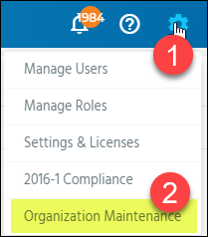
 | To add a new one, select Company and then choose the Add icon. | 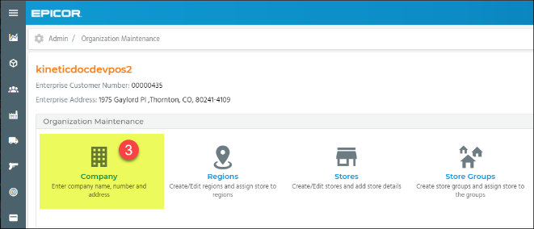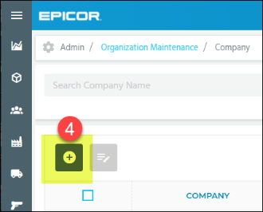
 | Enter the company name and company.  The company number may contain up to six digits.  Select Save. | 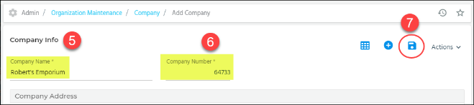
 | Use the plus button to add the company address.  Fill in the required information denoted with the red asterisk.  The Address Description could be location or type.  For example, the location may be most familiar to employees as something like the old warehouse or the New Lumber Yard.  Toggle the Primary switch to yes if this is the company primary address.  When finished, select OK, then choose Save to save the changes.  Once saved, the address displays in the Company Address section. | 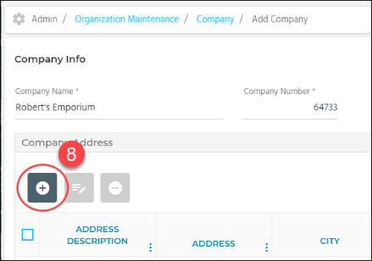  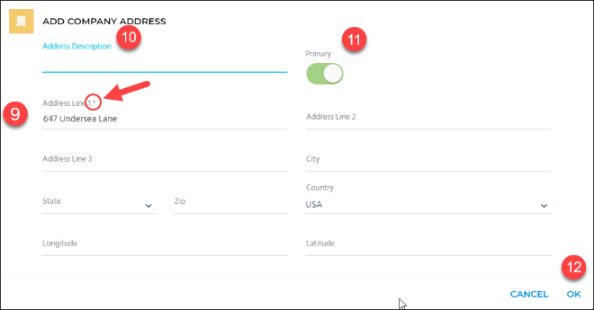  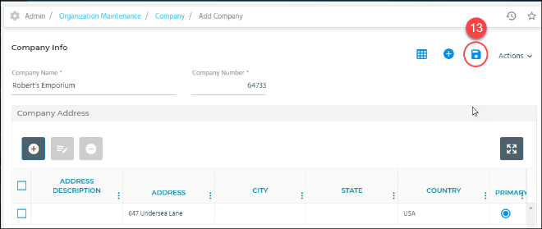  Callout the address description and toggle with the audio
 | You can edit a company by selecting the related checkbox and tapping the Edit button. | Make sure the company names make sense and there is no junk data.

Topic B – Set Up a Region
 | Narration | Action/Notes
 | Regions can help you organize multiple locations.  From the main screen, select the Admin icon and choose Organization Maintenance. | 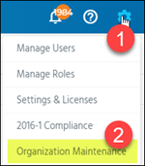
 | Select Regions.  Choose the Add icon. | 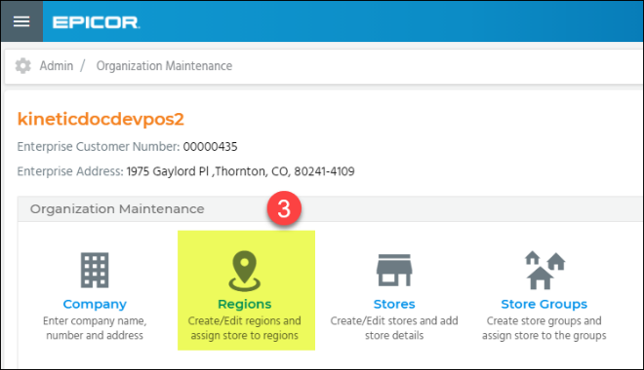  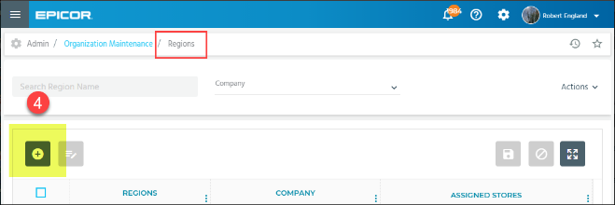
 | On the Add New Region window, use the drop-down list in the Select Company field to choose the related company and then enter a Region name.  For example, if you have 10 locations and 3 are in the Northwest part of the state, you can name your region accordingly. | Add a region called Northwest Locations.
 | If you already have stores set up, select them from the drop-down list  Every store should have a region assigned to it.  This is used primarily for reporting purposes. You cannot add stores already assigned to different regions.  Choose OK. | 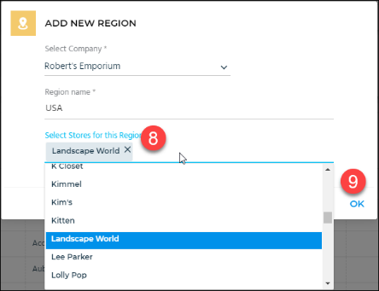  Make sure the store names are good. Nothing about Ace.
 | Select Save to save the changes.  Again, you can edit any information by enabling the checkbox and tapping Edit. | 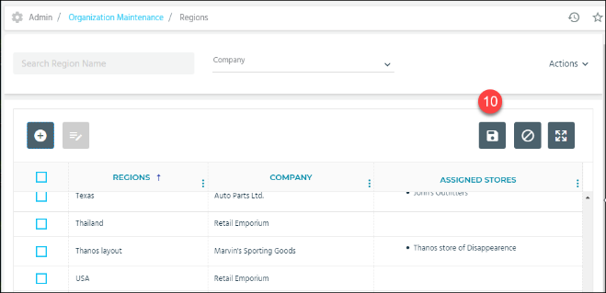

Topic C- Set Up a Store
 | Narration | Action/Notes
As your business grows, you may need to add more locations.

From the main screen, select the Admin icon and choose Organization Maintenance.

 | Select Stores and choose the Add icon to display the Add New Store page. | 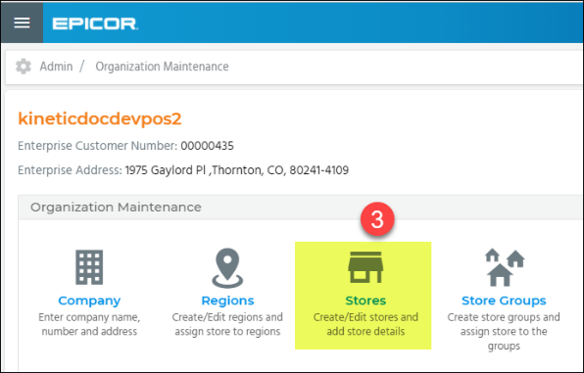
 | Fill in the required information denoted with the red asterisk.  Enter the default point-of-sale customer name.  This is the account that will populate each transaction in point-of-sale.  The customer record must already exist in your data but remember, you can come back and edit this if needed. | 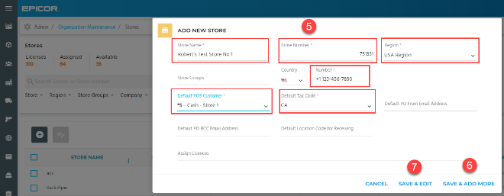  Call out the default pos customer name field with this sentence
 | Enter the Default Location Code for Receiving.  This may be your receiving dock or a staging location in your warehouse used to unpackage items before putting them away in their normal locations.  The Default Location only applies when receiving items with blank location codes. | Add a location code called NEW if there is not one already.
 | You can identify a default tax rate to be charged during a transaction and a default email address that will be used when you send a purchase order to a supplier. | 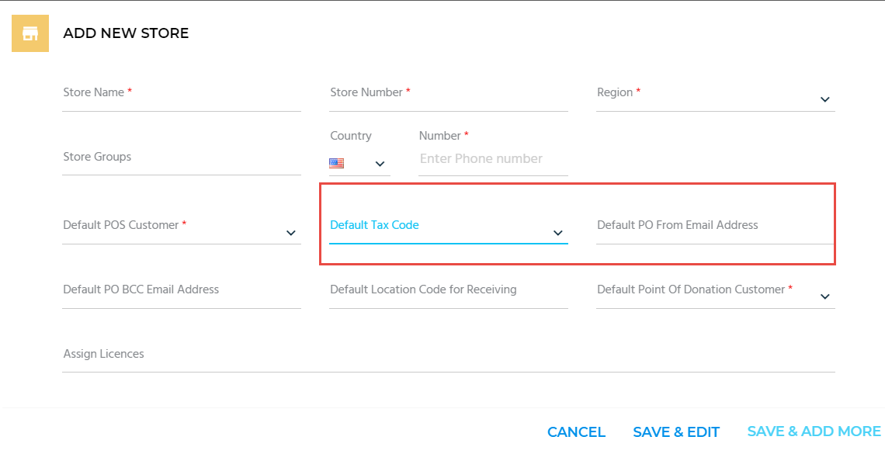
Select Save & Add More to add more stores.

When finished, select Save & Edit to save and proceed to the Edit section.
 | The Edit section opens to the Store Information tab.  To add store address(es), select the Store Address tab and choose the Add icon. | 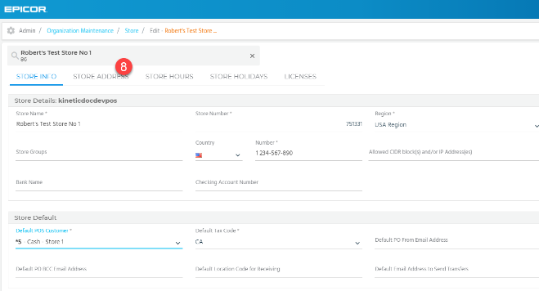  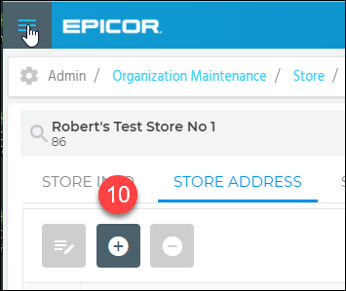
 | Fill in the mandatory information denoted with the red asterisk.  Enable the Primary toggle switch if the address you entered is the primary address for this store.  When finished, select OK. | 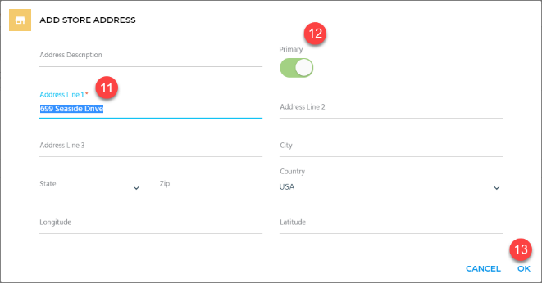
 | On the Store Hours tab, select the time zone from the drop-down menu.  Toggle the Closed? switch for days when the store is closed.  Then enter the regular open and close time.  When finished, select Save. | 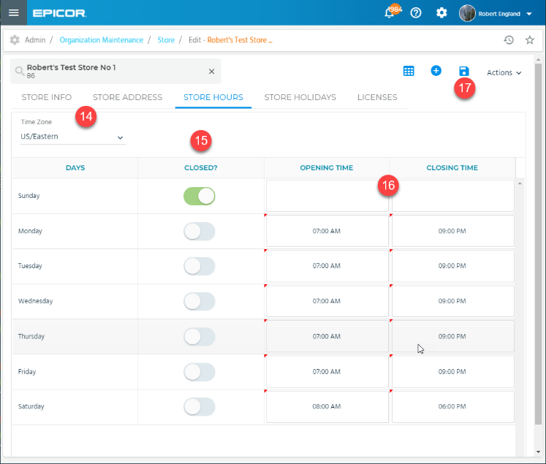
 | Select the Store Holidays tab and choose the correct Year from the filter  Use the Add icon to set up a full or partial day store holiday.  Press Save when you are done. Note that you can only add holiday that occur in the future. | 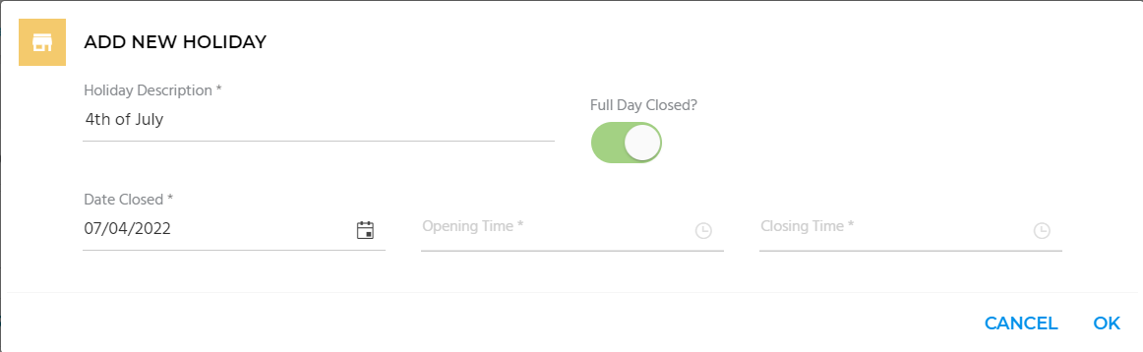

Topic D - Set Up a Store Group
 | Narration | Action/Notes
Add a store group if you want to categorize your locations.

For example, you may want to track activity in all stores that have a greenhouse or nursey.

From the main screen, select the Admin icon and choose Organization Maintenance.
 | Select Store Groups.  Select the Add icon to display the Add New Store Group page. | 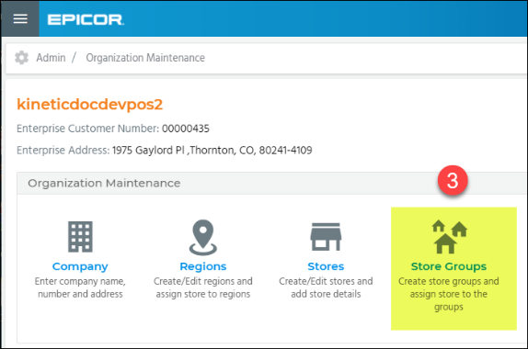  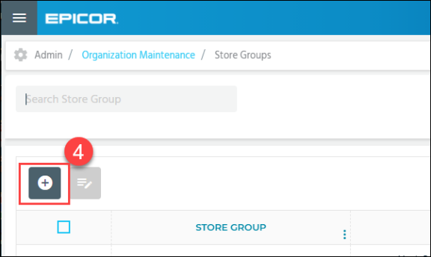
 | In the Store Group Name field, enter a name.  Store Group Names must have at least two characters. | Add store group called Retail Branches.
Select the stores to add to this group from the drop-down menu.

When finished, choose Save.

Once again, you can choose any Store Group from the list, check the related box and tap Edit to make changes.

Recap
 | Narration | Action/Notes
 | Accurate company and store data ensure that your records are in order.  Using regions and store groups can help you report on that data and manage your growing business.  For more information on this topic, refer to online Help. | Setting Up Companies, Stores, and Regions  Use the same theme of icons as in the intro
 | In this course, we showed how to set up a company, a region, a store, and a store group.  We also covered the edit process. | Objectives:  - Topic A Button Text: Set Up a Company  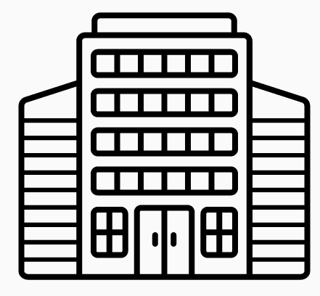  - Topic B Title Text: Set Up a Region    Topic C Title Text: Set Up a Store    Topic D Title Text: Set Up a Store Group  