# AP Assist Overview Options and Security

**Options Configuration**

The following options are required to use AP Assist Import:

* Option 8628 – Windows Advanced Receiving on System
* Option 1188 – Advanced Receiving Activated
* Option 1704 – AP Assist Import on System?

These options can only be changed by an Epicor Licensing Representative as they are MSY password protected.

The following options will be available once Option 1704 ‘AP Assist Import on System?’ is set to ‘Yes’:

* Option 3233 – Invoicing threshold percent
* Option 3234 – Invoicing maximum threshold amount

These options are considered the default threshold percentage and amount. The threshold percent should be set to the maximum allowed percentage difference allowed between the actual invoice amount and the receiving invoice amount. The maximum threshold amount is the dollar amount that should never be exceeded regardless of the threshold percentage.

Example: If the threshold percent entered in Option 3233 is 2.00% and threshold maximum dollar amount entered in Option 3234 is $100:

* The amount that will be tolerated is 2% but will not to exceed $100.
* On a $10,000 invoice, 2% would be $200 which exceeds the max dollar amount so the actual threshold allowed would be $100.
* If the amount of the invoice is $3,800, 2% would be $76 which is less than the maximum amount of $100, so it would be an allowable variance.

If a vendor requires a different threshold percentage and amount defined, the EDI Invoice Options on the ‘Order Info’ tab in Vendor Maintenance are available:

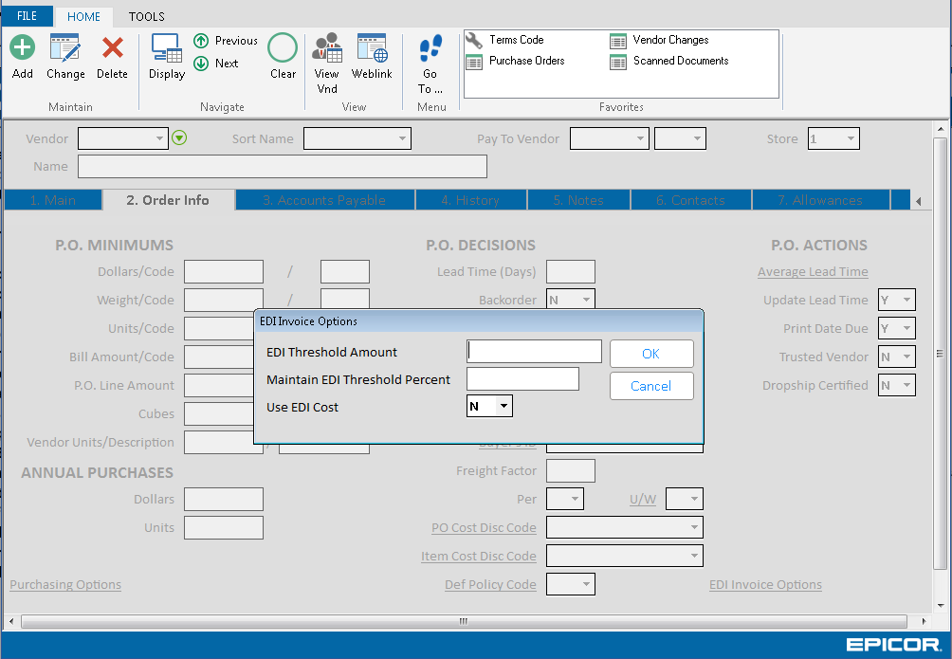

**Security Maintenance**

The following security bit is required to access the AP Assist Viewer in Eagle for Windows:

Bit 1134 – Access AP Assist Processing Viewer

Bit 792 – Allow change of header fields in WinMRV

Bit 793 – Allow update of AP Voucher fields in WinMRV

The contents of this document are for informational purposes only and are subject to change without notice. Epicor Software Corporation makes no guarantee, representations or warranties with regard to the enclosed information and specifically disclaims, to the full extent of the law, any applicable implied warranties, such as fitness for a particular purpose, merchantability, satisfactory quality or reasonable skill and care. This document and its contents, including the viewpoints, dates and functional content expressed herein are believed to be accurate as of its date of publication. The usage of any Epicor software shall be pursuant to the applicable end user license agreement and the performance of any consulting services by Epicor personnel shall be pursuant to applicable standard services terms and conditions. Usage of the solution(s) described in this document with other Epicor software or third party products may require the purchase of licenses for such other products. Epicor, the Epicor logo, and are trademarks of Epicor Software Corporation, registered in the United States and other countries. All other marks are owned by their respective owners. Copyright © 2016 Epicor Software Corporation. All rights reserved.