# Eagle Text Messaging Overview

# Review the following options settings prior to using Eagle Text Messaging.



# Verify that option 1673 “Text Messaging (SMS) available on System” to Yes. If the option is not set to Y, contact Epicor Direct at 800.538.8597.

# Choose the appropriate scenarios to send a text with option 1674 “Send text message notifications to customers for these events”.

# Select ‘R’ to send text once a rain check item is back in stock.

# Select ‘S’ to send text once a special order item is received.

# Select ‘M’ to send text once a service/repair order has a status change.

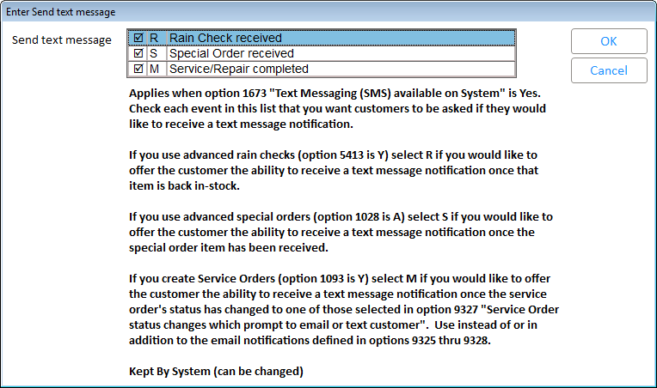

# Within option 1678 “Text for start of text message”, enter the text you want at the start of each text message or leave this blank to have your store's ‘Short Name’ begin each text message.

# Use option 1679 “Text for end of text message” to enter the text you want at the end of each text message. For example: "Do Not reply to this message" or "Call xxxxxxxxxx for more details"

# Option 1684 “Default for prompt to text customer when Service Order status changes” should be set to ‘Yes’.

# Use option 9327 “Service Order status changes which prompt to email or text customer” to select each type of status change which should generate a text notification. This option also applies to the existing functionality of ‘notification by email’ option 9325.

# 

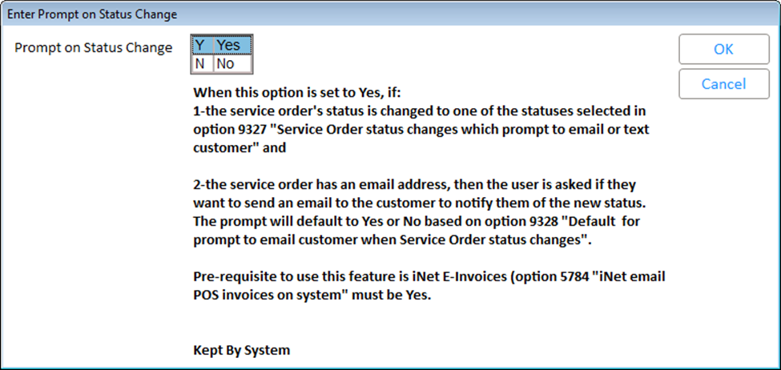

On Epicor Eagle Release 26.1 and higher, 3 new options allow the user to define their own ‘end of text’ message for Rainchecks, Special Orders, and Service Orders. If blank, the text in Option 1679 "Text for end of text message" will be used.

* 1720 “Text for Rain Check Received 'end of text' message”
* 1721 “Text for Special Order Item Received 'end of text' message”
* 1722 “Text for Service Order Status Changed 'end of text' message”

Nonspecific text messages will be available in the Customer Activity Notes viewer.

You must have Option 3600 “Eagle for Windows Customer Activity Notes on system” set to Yes.

The contents of this document are for informational purposes only and are subject to change without notice. Epicor Software Corporation makes no guarantee, representations or warranties with regard to the enclosed information and specifically disclaims, to the full extent of the law, any applicable implied warranties, such as fitness for a particular purpose, merchantability, satisfactory quality or reasonable skill and care. This document and its contents, including the viewpoints, dates and functional content expressed herein are believed to be accurate as of its date of publication. The usage of any Epicor software shall be pursuant to the applicable end user license agreement and the performance of any consulting services by Epicor personnel shall be pursuant to applicable standard services terms and conditions. Usage of the solution(s) described in this document with other Epicor software or third party products may require the purchase of licenses for such other products. Epicor, the Epicor logo, and are trademarks of Epicor Software Corporation, registered in the United States and other countries. All other marks are owned by their respective owners. Copyright © 2016 Epicor Software Corporation. All rights reserved.