Review the following Options Configuration and Security settings to use the ‘Bin Label Changes Viewer’ in conjunction with the Bin Label Print Report (RBL) or Label Manager function.

Option 3070 must be set to ‘Yes’ in order to use the Item Change file to print bin labels.

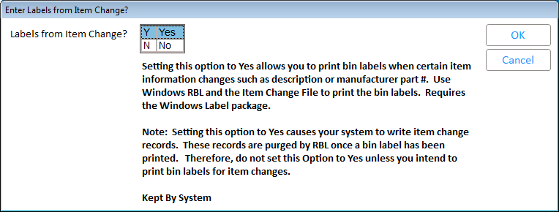

Option 3071 determines when an item is purged from the Change File. The default is 31 days, but if someone is addressing this file on a regular basis, you may want to set this to fewer days.

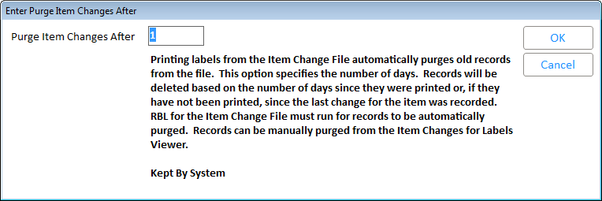

Security ID 703 must be set to ‘Yes’ to view the Bin Label Changes Viewer.

