You must perform the following steps ***before*** you launch your **True Value Rewards** program.

If you have any questions on any of the required configuration, please contact the Epicor Help Desk or use the Eagle Online Help.

1. Set the receipt printers to print at the End of the Transaction. See ‘**Device Configuration****’**.
2. Review the options listed and save any needed changes. Contact Epicor for any options that require a password. See **‘****Options Configuration****’**.
3. Establish a generic ‘TV Rewards’ coupon SKU in Inventory Maintenance.*
4. Enter a ‘Default Customer’ in MCR.**
5. Specify a ‘Default Customer’ for each POS terminal in your store.**
6. Review the listed Security Bits and assign to Roles accordingly. See **‘****Security Bits’**.
7. Discuss the procedure to add TVR numbers to In-house Charge and Commercial accounts. **
8. Train and review with your staff the steps to process a True Value Rewards transaction at POS.**
9. Print out the RLC report monthly and review with staff to ensure your store is working toward 50% or greater loyalty transactions.**

*See ***‘True Value Set Up’*** Training on Demand classfor more information on this step.

**See ***‘True Value Rewards Customer Maintenance & Quick Add’*** Training on Demand class for more information on these steps.

**Device Configuration**

Receipt Printers should be set to print at the End of the Transaction.

1. Open Options Configuration, (OPT from the Eagle Launch Bar) and press the ‘ID’ Button.
2. Enter **9959** in the ‘Access Option by ID’ box and press Enter.
3. Verify your setting in the ‘Current Value’ column.

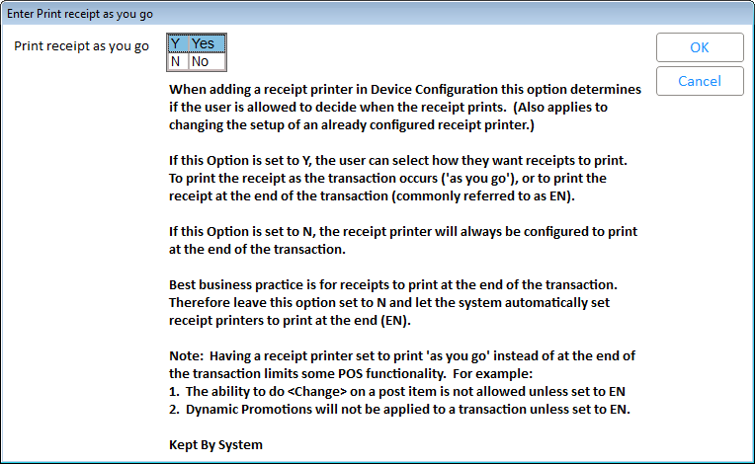

* If you have Option ID 9959 set to **No**, your system will set any Receipt Printer to ‘Print Receipt at end of transaction’. No further action is needed.
* If you have Option ID 9959 set to **Yes**, Open Device Configuration under the Eagle ‘Utilities’ menu.
  + Double Click the ‘Receipt Printer’ line in the grid to launch the ‘Receipt Printer’ dialog box.
  + Click the ‘When’ button and update the ‘Receipt Printer Option’ setting to ‘EN Print receipt at the end of the transaction’ and press ‘OK’.

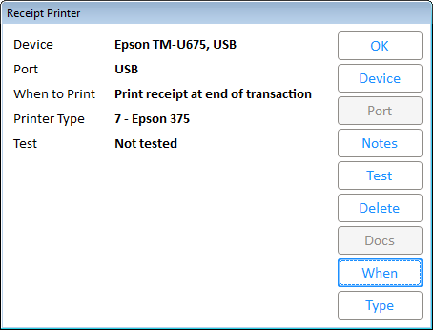

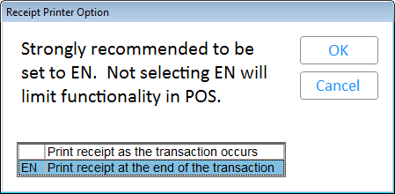

**Options Configuration**



*Check with your accountant and state.

**Security Bits**

