Table of Contents

Configuring Performance Manager 2

Minimum Eagle and Eagle for Windows PCO Levels 2

Eagle for Windows Options to Review – various combinations possible 2

Business Advisor (E4W) 2

Recommendations for Use 2

Getting Started with Performance Manager 3

Opening Performance Manager 4

Starting Page 5

Sales Summary Page 6

Sales Analysis Page 7

Inventory Page 8

Customers Page 9

Buying Page 10

Alerts Page 11

Analysis Page 13

Scorecards Page 14

Market Basket Page 15

Appendix 16

# Configuring Performance Manager

## Minimum Eagle and Eagle for Windows PCO Levels

Eagle PCO – 33.0732 - E4W Client – 21.0441

## Eagle for Windows Options to Review – various combinations possible

The following options are used to set defaults in Performance Manager:

**For Performance Manager (in a de-coupled mode without full Compass Analytics)**

1. MSY9901 – Linux
2. MSY2001 – Y for Full data base
3. E4W1017 – Compass Client
4. E4W1025 – Performance Manager on System
5. E4W43 – ITR on the System
6. E4W1031 – Market Basket on System
7. E4W9697 – Number of Concurrent Queries (Leave at default value for now)
8. MSE992 – Access to Sensitive Data on Performance Manager
   1. Alerts
   2. Scorecards
9. MSE977 – Access to Performance Manager

**For Performance Manager – with Analytics**

1. E4W8829 - Eagle Analytics on System
2. MSE834 – Access to Designer Mode
3. E4W8833 – Number of Analytics Terminal Licenses

## Business Advisor (E4W)

Performance Manager will use the summary tables (when efficient to do so) from E4W Business Advisor. While Epicor Direct will be targeting folks that currently have Business Advisor, there may be instances where a customer for some reason doesn’t have Business Advisor enabled.

In those cases, we will need to setup the QUEs that populate the summary tables. However, we will not be required to change MSY1181 to Yes. The RIV, RAG, and other reports that supply the summary tables can run without the MSY1181 flag being set. In many instances, the QUEs that populate these tables will already be setup and enabled.

In the case where E4W Business Advisor Summary data is not available, some of the Performance Manager screens may not show meaningful data.

## Recommendations for Use

Performance Manager utilizes a launch page as a starting point for all other areas of the application. The starting page is accessible from the menu under the applications heading. The starting page has a number of detailed graphs along with a launch bar at the bottom. This launch bar is how a user launches other pages such as Sales, Inventory, Customers, etc.

Epicor recommends that a user opens the three or four pages that represent their area of responsibility (e.g. a Store Manager may open the Start Page, the Inventory Page, the Customers Page and the Scorecards Page) and save that as a Layout. In the future, the quickest way to find the pages in which a user is interested will be to open that saved Layout. Of course, anyone with proper security can open up any page they wish at any time.

**Epicor DOES NOT recommend opening up all pages of Performance Manager at once. Doing so could cause the user’s PC to use all of its memory and perform in a sluggish, non-satisfactory manner.**

**2/1/2012   
SCREEN RESOLUTION** – Many users will have some older equipment that may not be capable of displaying the Performance Manager screens at the minimum of 1280 X 1024. If you see a lot of scroll bars, try to edit the Windows OS screen resolution to at least 1280 X 1024.

**2/1/2012  
MQK in Eagle** – Understanding and explaining the difference between Eagle database and TFP or the MySQL database will really help offset some potential problems dealing with settings in MQK. For example, if a customer has Cash Customers set to 6 months in MQK, Performance Manager’s graphs that compare today to same day last year will show drastically low numbers for last year. The reason for this is that when TFP is enabled, whatever is in Eagle comes over to the MySQL database. If Quick Recall only has 6 months of cash customer invoices, then the comparatives will not reflect properly for six months.

**2/1/2012  
Explanation of TFP** – Take time to explain the difference between the two databases.

**2/1/2012  
FISCAL COMPANIES:** - Release 9 of Compass will have these issues fixed –

**2/1/2012  
LOYALTY REPORT in ANALYSIS SCREEN:** - Remove off of the list of reports -

# Getting Started with Performance Manager

Options Settings

Once Compass is open on your screen, choose <Tools> and <User Options>.

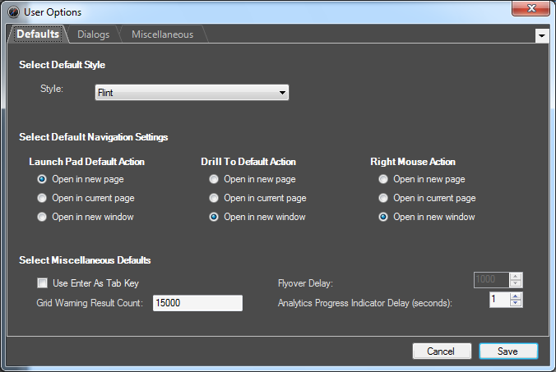

The three tabs help customize how the user would like to interact with the application. The settings in these tabs are saved for each individual user. Individual options will be reviewed during the training and implementation.

# Opening Performance Manager

Once Compass is open on your screen, navigate to the Launch Pad, Main Menu, Applications, and select Performance Manager.

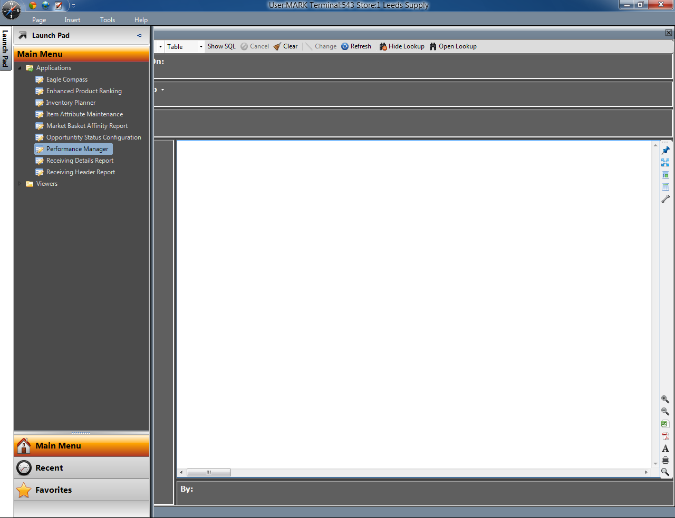

# Starting Page

The **Performance Manager Starting Page** will open.

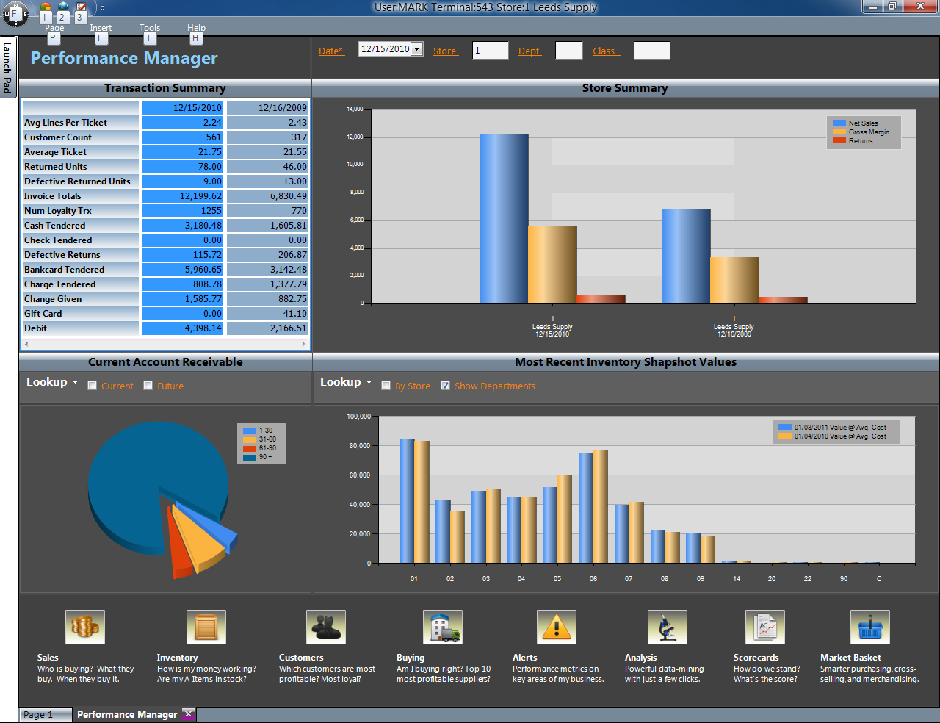

Navigation

A convention used throughout the application and on nearly every page is Page Context. Page Context is found in the top area of the page. When data in page context is changed, the top seven work areas and the “Current Inventory Value” work areas are refreshed to reflect that change. Current Accounts Receivable does not submit to page context.

PAGE INFORMATION: ***Transaction Summary*** lists various key sales metrics for data found in page context area (defaults to ‘today’ when application opens). ***Store Summary*** shows key sales metrics by Store compared to last year. ***Accounts Receivable*** shows as current aging buckets and ***Inventory Snapshot*** shows most recent summary table entries (these entries will be from the last time RIV was used to update Business Advisor tables).

Launch Bar

Clicking on any of the icons near the bottom of the starting page will launch that specific page. A user will need MSE992 to access Alerts or Scorecards pages.

# Sales Summary Page

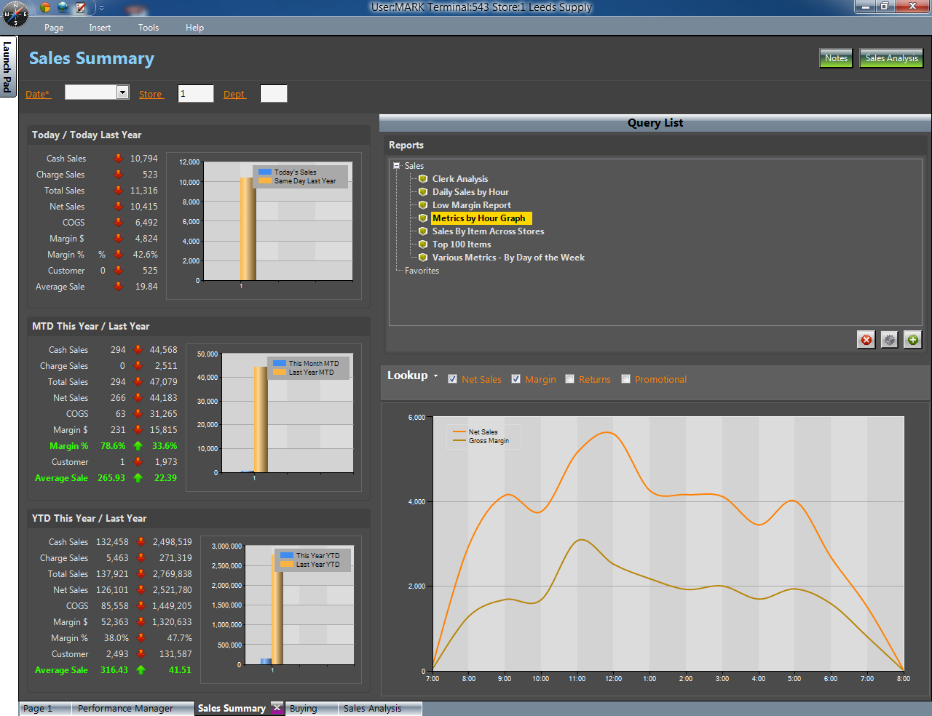

The Sales Summary Page utilizes Page Context for the left half of the page. This left side consists of three main areas – Today vs. Same Day Last Year, MTD vs. Same Month MTD Last Year, and YTD vs. Last Year YTD.

The area on the right consists of a query list on top and results display area on the bottom. This half of the page does not respect page context – each query will have its own criteria presented in a Lookup area. A user can add Epicor supplied queries to the list by clicking the “Plus” icon, remove a query from the list by clicking the “Red X” icon, or reset to shipped default by clicking the “Gear” icon. Double clicking on a query in the list will display results in the bottom area.

Analytics licensed users can create their own queries and add them to this list.

At the top of this screen is a “Notes” button that will allow a user to enter specific notes about weather or other unique business conditions. One note per store per day is allowed – existing notes can be modified, edited, or otherwise appended. The “Sales Analysis” button takes you to a different page with more extensive analysis regarding sales activity.

# Sales Analysis Page

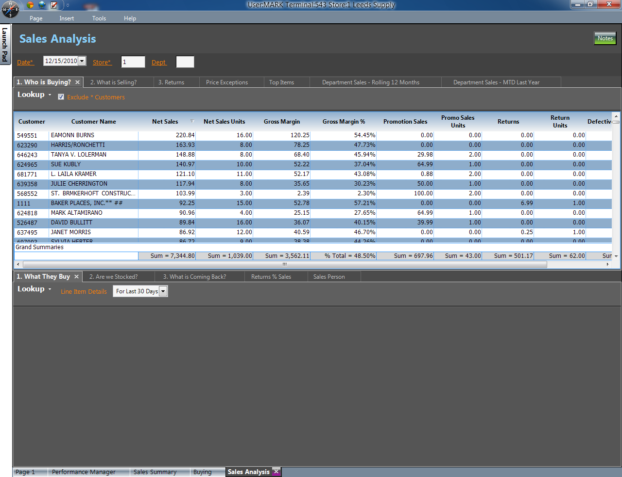

The Sales Analysis Page consists of a top work area and a bottom work area. Each work area has tabs. A tab on the top work area has related drill down results on the bottom work area by the readable number on the tab. In the above screenshot, tab “*1. Who is Buying”* has a drill down that produces results on the bottom inside tab “*1. What they Buy”* and so on. This convention is used on nearly every page. Tabs that have no number stand alone and have no predefined drill downs associated with them.

At the top of this screen is a “Notes” button that will allow a user to enter specific notes about weather or other unique business conditions. One note per store per day is allowed – existing notes can be modified, edited, or otherwise appended.

* *Who is Buying* – as transactions occur (or for historical dates), most recent transactions at the top, actual customer transactions.
* *What They Buy* – actual transaction line-item detail for the last year – double clicking any line in the grid shows E4W Quick Recall Transaction information.
* *What is Selling* – sales detail for page context descending quantity sold by department
* *Are we Stocked* – a quick glance at movers and their order point, on-hand, and on-order information
* *Returns* – credit transactions for page context date(s)
* *What is Coming Back* – Line item detail for the credit transactions
* *Top Items* – top 100 by various measure in the drop down box
* *Price Exceptions* – Items selling different than system price
* *Return % Sales* – a quick look at returns as a percent of sales
* *Sales Person* – quick glance at sales person productivity for page context dimensions
* *Departmental Sales – Rolling 12 Months* – MTD information for net sales last 12 months from page context date
* *Departmental Sales* – *MTD Last Year* – enter a date and see the MTD for Last Year for various Sales related metrics. This particular tab is independent of page context

# Inventory Page

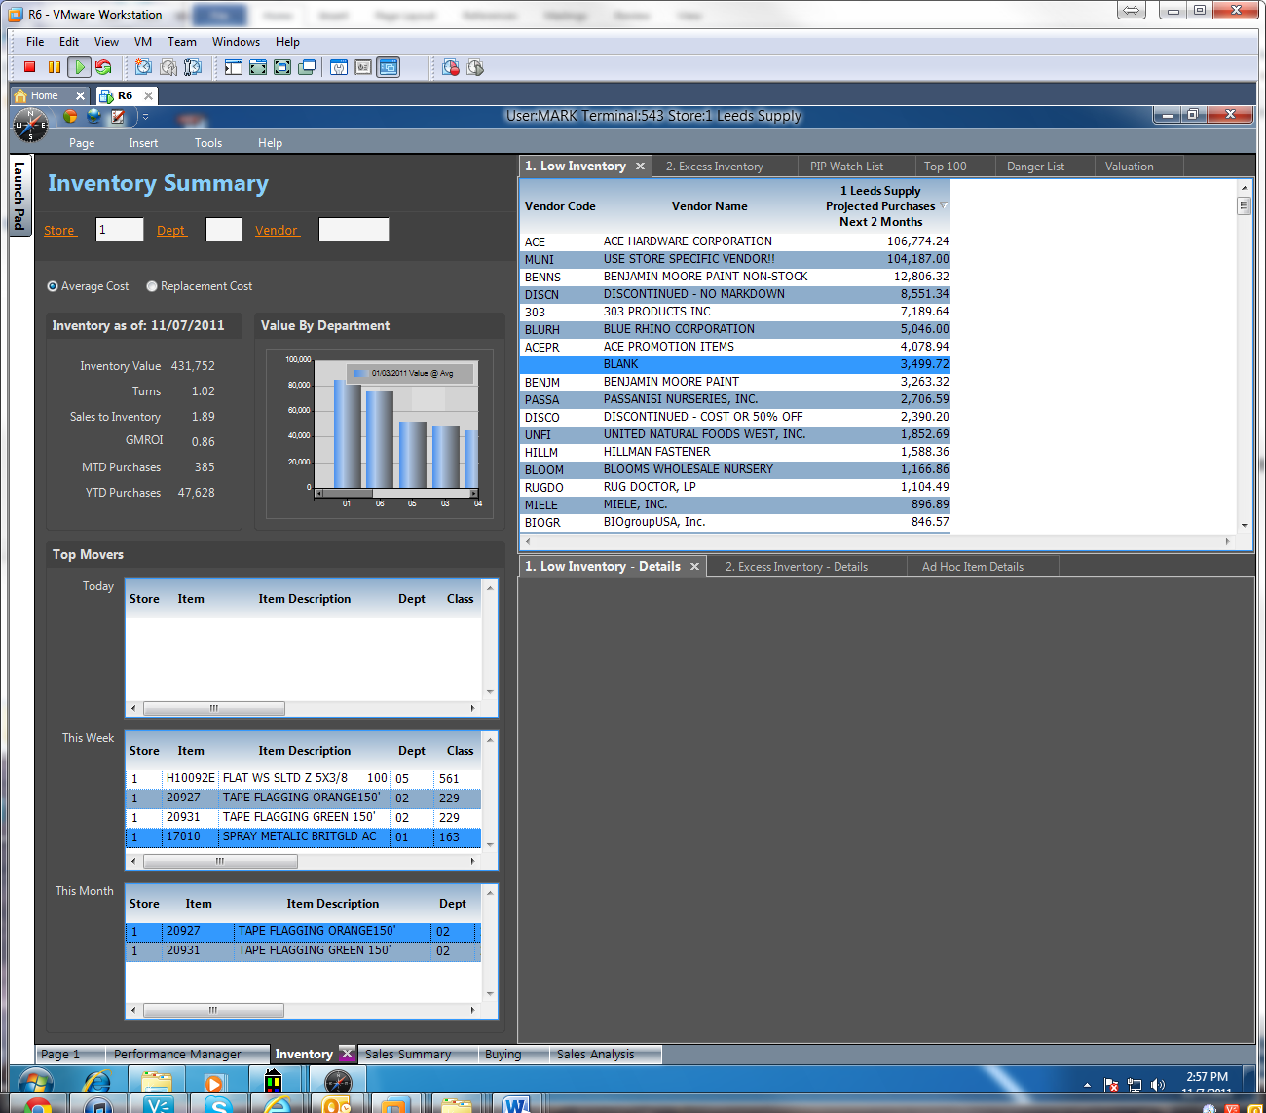

The Inventory Page utilizes Page Context.

The area on the left shows quick-hit information on inventory value by department as well as a running RDI by Day, Week, Month for top moving items. To see more columns, right click and select “Full Screen” or “Designer View”.

The area on the right consists of work areas. A top work area and a bottom work area. Each work area has tabs. A tab on the top work area is related to a tab on the bottom work area by the readable number on the tab. In the above screenshot, the tab *1.Low Inventory* has a drill down that produces results on the bottom inside tab *1. Low Inventory - Details* and so on. This convention is used on nearly every page. Tabs that have no number stand alone and have no predefined drill downs associated with them.

Licensed Analytics users can create their own drill downs, build their own queries, and modify existing queries.

* *Low Inventory* – by Vendor, subtotal of potential lost sales based on target inventory and next 2 period sales units
* *Low Inventory* – Details *–* Item and store
* *Excess Inventory* – by Vendor, subtotal quantity-on-hand > next 6 periods sales
* *Excess Inventory* – *Details* – Item and store
* *Top 100* – Top items by various measures within date range
* *PIP Watch List* – Items not counted in last number of days – select the drop down box
* *Danger List* – by Velocity, items whose QOH + QOH < Order Point
* *Valuation* – Valuation by Department, Class, and Fineline
* *Ad Hoc Item Details* – quick look at item detail valuation details – click the check boxes to provide desired level of detail

# Customers Page

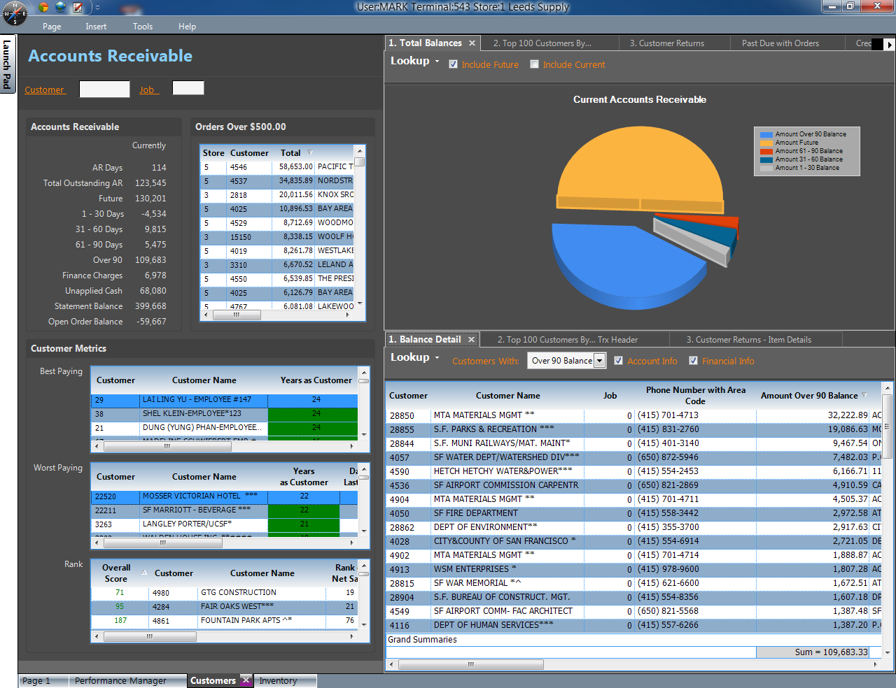

The Customers Page utilizes Page Context.

On the left is a list of customers that have orders over $500.00. Double clicking on a row will bring up a list of that customer’s orders in the Eagle Document viewer. Under the Customer Metrics area are three categories of customers – Best Paying, Worst Paying, and overall Rank. Edits to these measurement criteria require Compass Analytics. To see more columns, right click and select “Full Screen” or “Designer View”.

On the right is a top work area and a bottom work area. Each work area has tabs. A tab on the top work area is related to a tab on the bottom work area by the readable number on the tab. In the above screenshot, the tab *2 Top 100 By…* has a drill down that produces results on the bottom inside tab 2*.Top 100 By… - Details* and so on. This convention is used on nearly every page. Tabs that have no number stand alone and have no predefined drill downs associated with them.

Licensed Analytics users can create their own drill downs, build their own queries, and modify existing queries.

* *Total Balances* – Graph of current AR position
* *Balance Detail –* change drop down selection and check boxes to attain desired level of detail – double clicking on a row brings up that customer’s transactions from which you can drill to a Quick Recall document on the Eagle
* *Top 100 By…* - change drop down to see top 100 customers by different measures and by different date ranges
* *Top 100 By… - change date ranges for more refined details*
* *Customer Returns –* returns by date range by customer
* *Customer Returns –* Details – refined information regarding customer returns
* *Past Due with Orders –* customers running behind that are still ordering from you
* *Credit limit danger –* Percent of credit limit currently used

# Buying Page

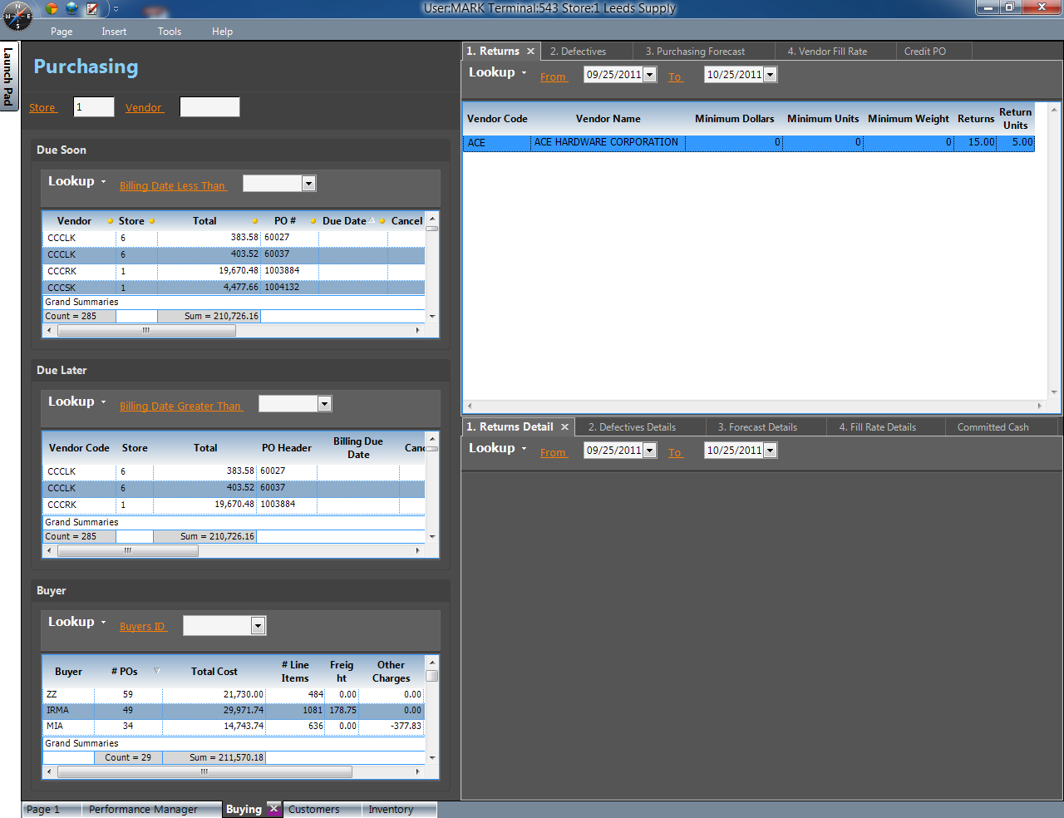

The Buying Page utilizes Page Context.

The area on the left consists of quick-glance information to purchase orders that are coming due soon.

The area on the right consists of work areas. A top work area and a bottom work area. Each work area has tabs. A tab on the top work area is related to a tab on the bottom work area by the readable number on the tab. In the above screenshot, the tab *1 Returns* has a drill down that produces results on the bottom inside tab 1*.Returns Detail* and so on. This convention is used on nearly every page. Tabs that have no number stand on their own merit and don’t have predefined drill downs associated with them.

Licensed Analytics users can create their own drill downs, build their own queries, and modify existing queries.

* *Returns –* by Vendor
* *Returns Detail –* POS line item detail
* *Defectives –* by Vendor
* *Defectives Detail –* POS line item detail
* *Purchasing Forecasts –* actual to target comparisons by velocity
* *Forecast Details –* quick snapshot to see if you are over or under budget by vendor by store
* *Vendor Fill Rates –* this year vs. last
* *Vendor Fill Rate Details –* key metrics by vendor that could indicate other concerns regarding a vendor such as Days Late and Rejected Items percentage
* *Credit PO –* quick check of vendor
* *Committed Cash –* based on date due (next 30, 60, 90, 90+ days) the amount of cash that will be required … cash that is committed

# Alerts Page

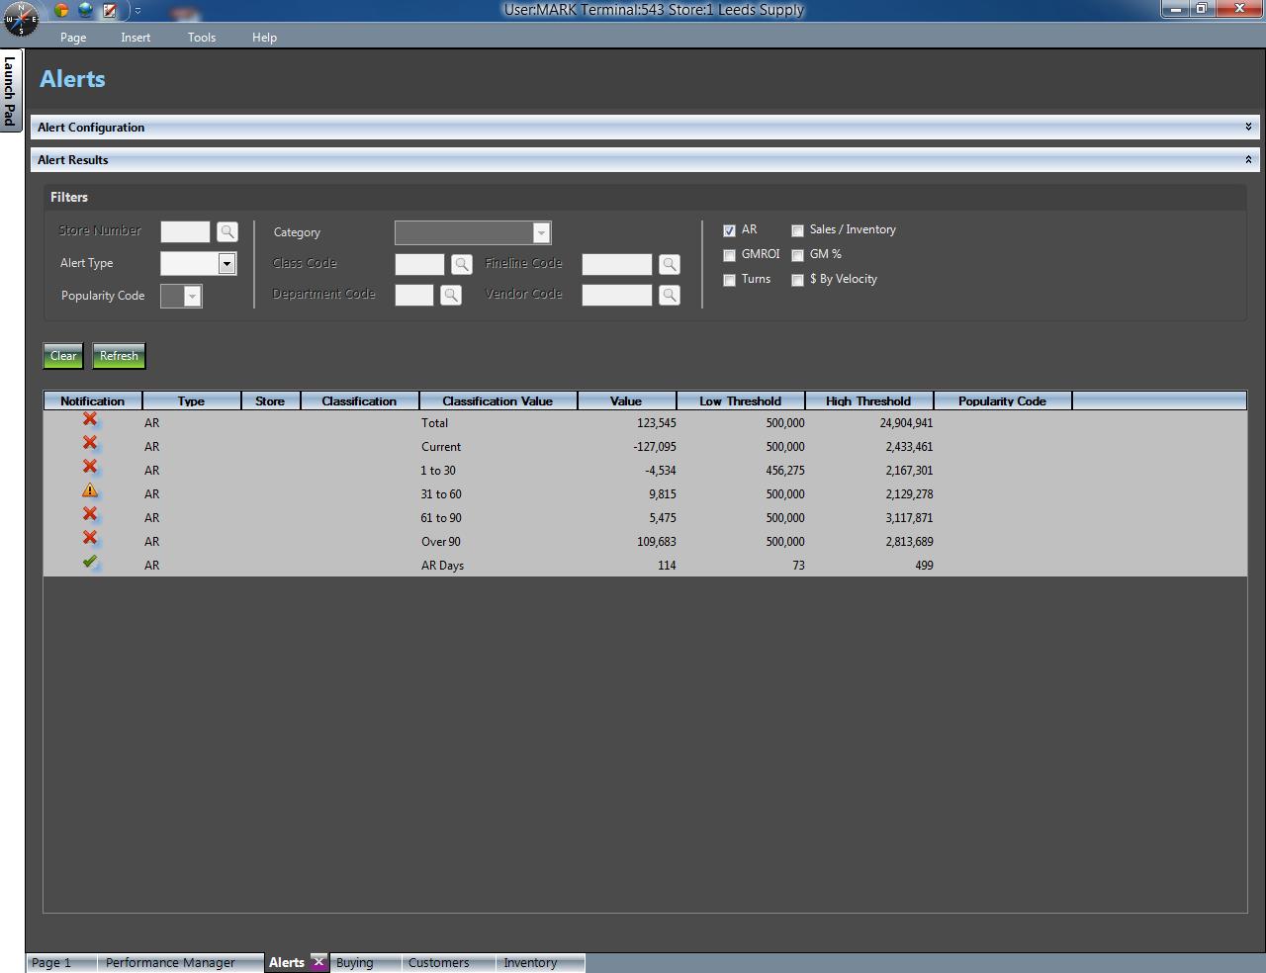

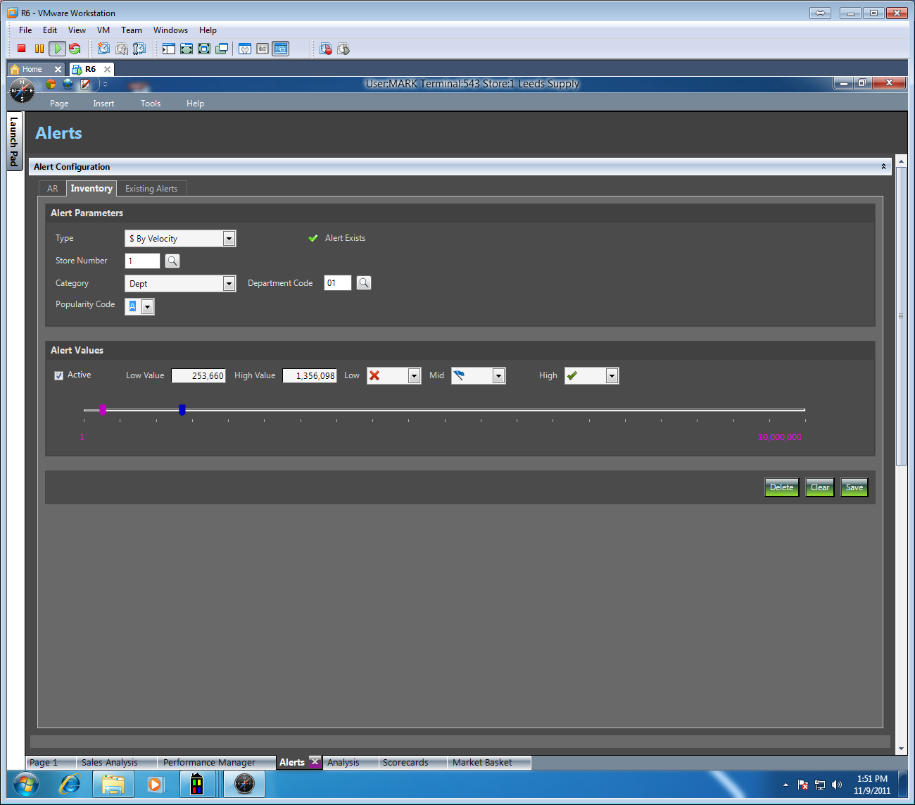

The Alerts page has two disclosure areas. One disclosure area is for configuring alerts and the other disclosure area is for displaying alert results.

Alert Configuration allows you to configure AR alerts and Various Inventory Alerts. Start by selecting the appropriate alert parameters. Then set thresholds by typing a Low Threshold and a High Threshold value. Next, select the related icon for each area (Low, Middle, or High) of the alert spectrum. Then click “Save” at the bottom of the screen.

A user can also see all existing alerts. Double clicking an existing alert will allow you to easily edit any information regarding the alert.

Alert Results allows the user to see which areas of the business are performing well or that perhaps need attention. Double clicking on the alert results will provide a list of items or customers that meet that alert criteria.

# Analysis Page

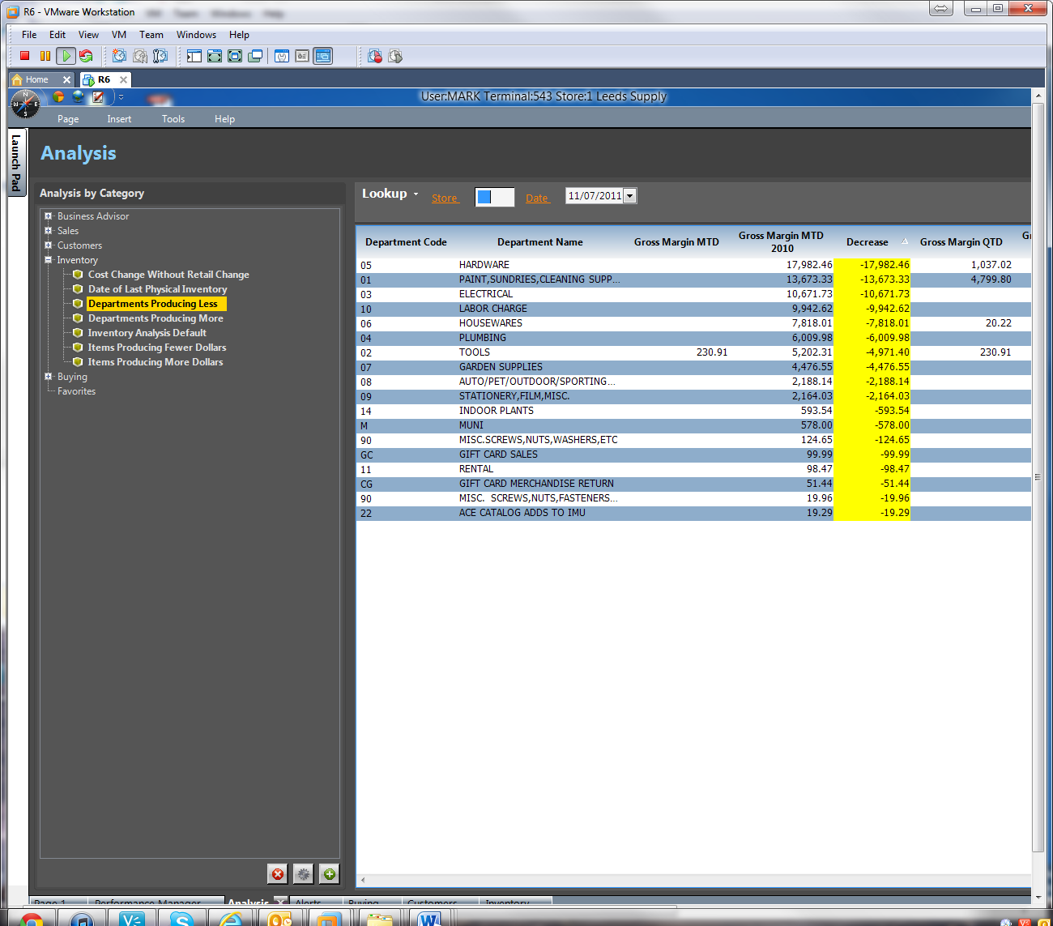

The Analysis consists of favorites from our customers as well as many that have been requested over the years – to add your own favorites, Analytics users can click the “plus” sign at the bottom and select from your saved-query dialog.

To see the results of a query, simply double-click the named query on the left and the results will show on the right.

To re-arrange the queries to a user’s preference, right click on a query and select “Edit Query Details” – then follow the prompts to move the query to a specific folder to the top level.

# Scorecards Page

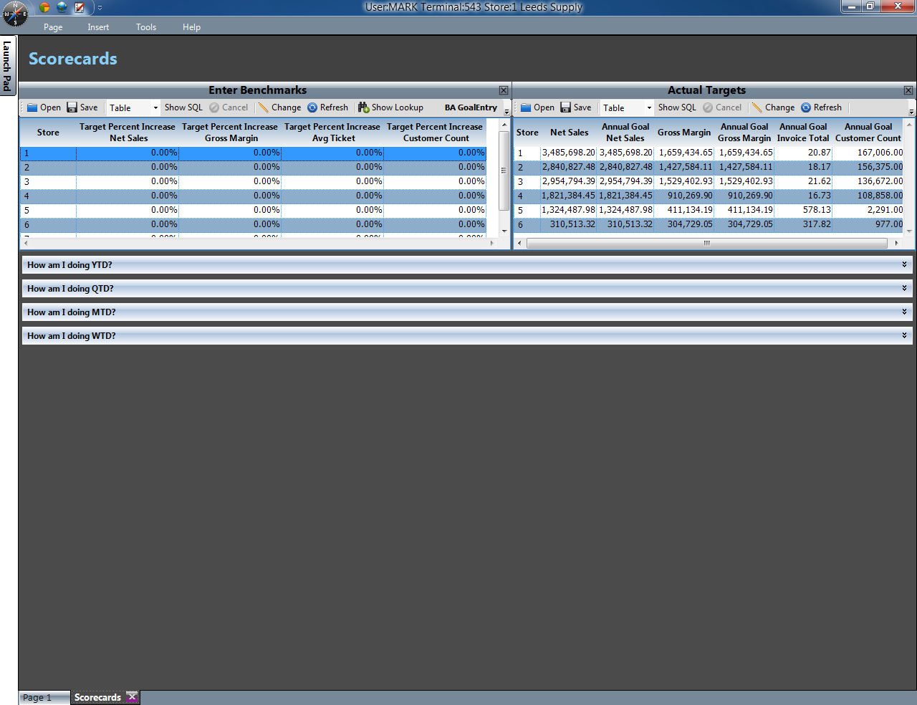

The Scorecard page allows the user to enter benchmarks or targets for different percentage increases in key areas of the business. Once new values have been entered the user can see how they are doing this week, this month, this quarter, and this year.

# Market Basket Page

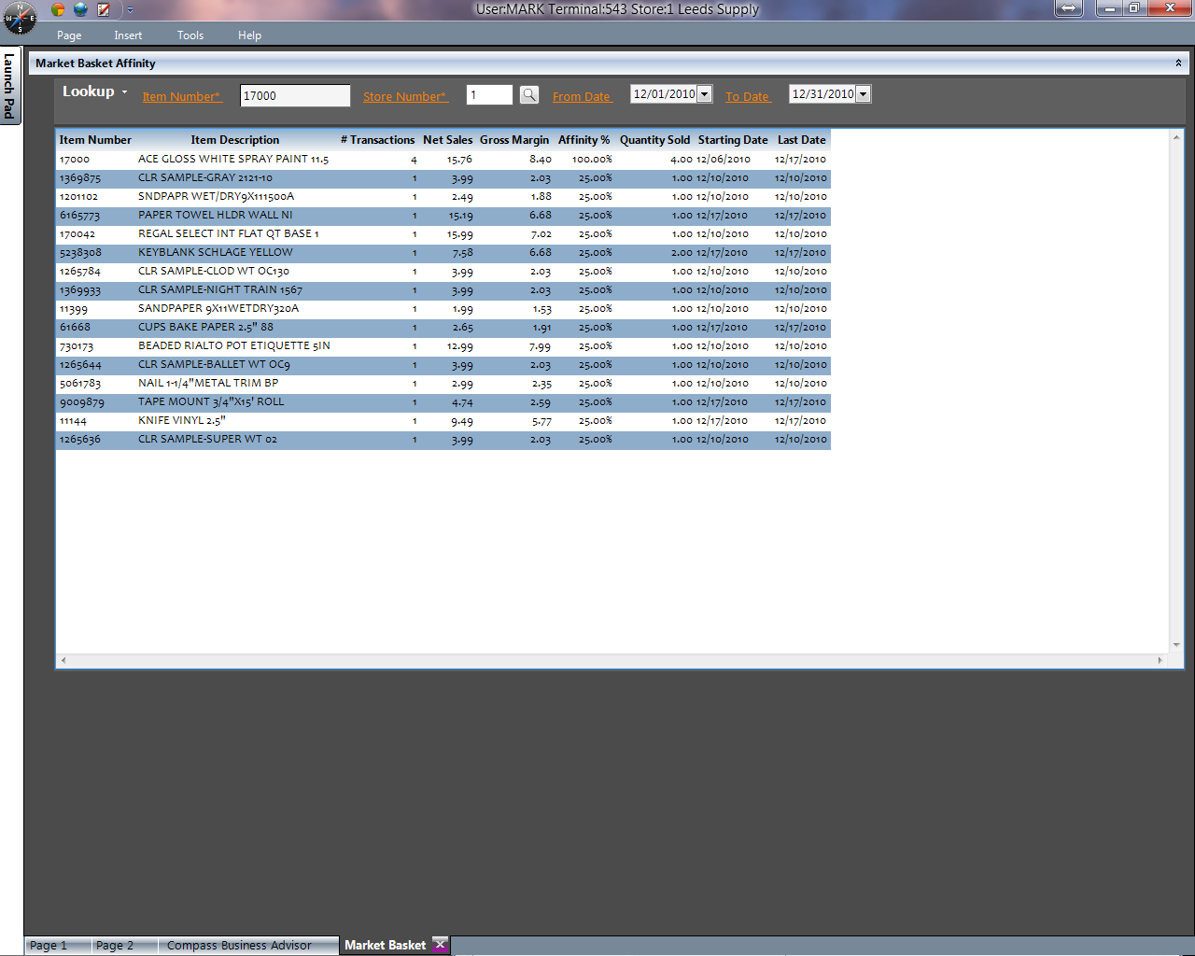

The Market Basket page allows for insight into the affinity of certain items to each other. In other words, whenever Item 123 sells, customers seem to buy item 456 a high percentage of the time.

Affinity analysis provides for better merchandising, purchasing, and cross selling.

Simply enter the SKU, Store and Date Range to see the results.

# Appendix

1. Designer View
   1. Designer View is available to all Analytics Users (E4W8829 set to Yes). Designer View is the ‘power’ of Performance Manager and is where a user can actually modify the query that is being viewed. Epicor shipped queries are not able to be modified but an Analytics user can <right click>, select <Designer View>, and <Save> any changes to a query that is Epicor defined.
2. Right Click Menu.
   1. The Right-Click (context) menu is very powerful and has many options depending on the screen position of the mouse when the right click event happens. Right Click menu controls formatting, designer view, full screen, column selection, insert column, formula, and many other functions. Specifics of Right Click will be covered in the training sessions. Items for which the user may not have access (i.e. Designer View) will be visible but disabled (not able to click).
3. Customizing the Pages in Performance Manager
   1. After making changes to a page a user may decide they want to keep those changes. Simply select <Page> from the menu and <Save Current Page> - if you want other users to see your changes, rename the page and select <System> as the scope. If you only want the new changes to be available, rename the page and select <User> as the scope. To restore back to Epicor shipped versions, simply select <Page>, <Open Page> , highlight your customized page, and click the <Delete> button.