Following is a list of several options that should be reviewed prior to using Advanced Special Orders in Eagle N Series.

**Option 51**

Option 51 determines whether or not you want the PO Number field in POS to default to "BUYER" for all special order items.

The Buyer's List is a grid containing all the items that have been marked with the PO number of "BUYER” and is used to create purchase orders for those items that need to be sourced.

Choose ‘Y’ if you always want special order items to appear on the buyer's list.

Choose ‘N’ if you don't want to use the Buyer's List feature.

**Option 9386**

You may want special order items added directly to a purchase order. If your vendors do not require an assigned purchase order number you can default the PO Number to "RSRV" by setting option ID 9386 to Yes.

However, this option is ignored if option 51 is answered ‘Yes’ and you are using the Buyers List instead of directly placing special order items on a Purchase order.

If you have set option 9386 to yes, you will also want to review the settings for the related options 9042, 9043 and 9390.

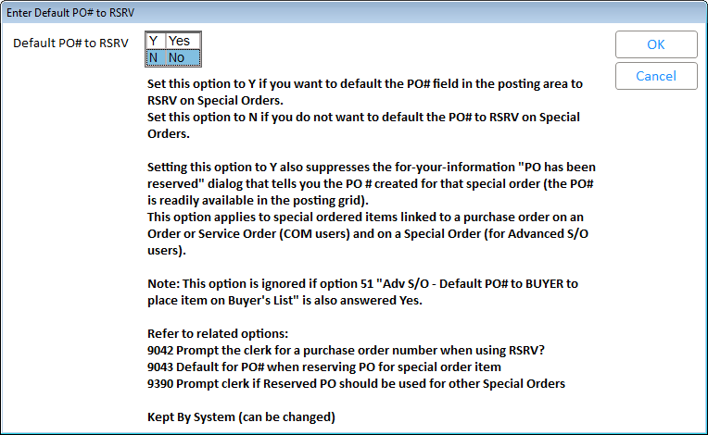

**Option 113**

To allocate the receipt of merchandise to specific customer special orders, set option 113 "Allocate Uncommitted Receipts?” to B or S. Allocation of receipts is covered in the ‘Advanced Special Orders – Workflow and Options’ Training On Demand class.

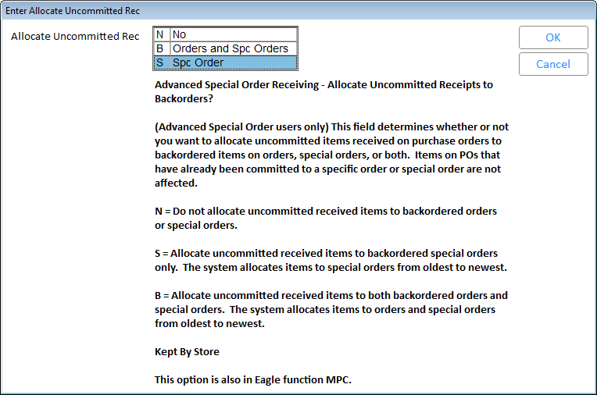

**Option 115**

Option number 115 determines whether or not you want a receipt ticket to print when you assign items on a PO to backordered special orders.

Selecting option S will trigger the printing of a receipt ticket for items that are allocated to special orders.

**Option 116**

ID number 116 determines what information prints on those receipt tickets. This option only applies if you entered an S for option 115.

**Option 114**

Option 114 determines if cost automatically updates on the POS document if it is changed during the receiving process. If items have been allocated on the RRP report (by the use of option P) and their cost was changed within MPO (Maintain Purchase Orders), then the cost will also be updated on the POS Order or Special Order. Best Practice recommends setting this to Yes.

**Option 1460**

If any cost changes are made on a purchase order you can have the Eagle system automatically update the sales order if option 1460 is set to Yes.

This setting, ‘Update special order item cost when cost is changed in MPO’, allows you to make sure the cost used in calculating the profit margin on special orders is accurate. Best Practice recommends setting this to Yes.

**Option 5447**

You will want to review option ID number 5447, “Check Quantity Insufficient on Special Orders”.

When this option is set to Y, POS will check for sufficient quantity for stock items – those that have the field ‘Keep Stock’ set to ‘Yes’ in IMU.

If the item's quantity available is enough to cover the quantity being posted to the Special Order, the system will leave the P.O. number in the posting area *blank* instead of setting it to ‘Buyer’ or ‘RSRV’.

This way, for example, if the customer has some other items to purchase that are already in your inventory and on hand, the system won't place those items on a Purchase Order or on the Buyers List. Best Practice recommends setting this to Yes.

**Option 16**

Finally, option ID number 16 should be set to ‘Yes’ so that you can check the receipt status of special orders from the POS window.