1. From your Windows screen, click on ‘Start’ in the lower left hand corner and then select ‘All Programs.
2. Navigate to the folder titled ‘Epicor’ and from there the ‘Epicor Compass’ folder.
   1. If any of these folders do not exist check with your System Administrator regarding installation of the Compass Client Software.

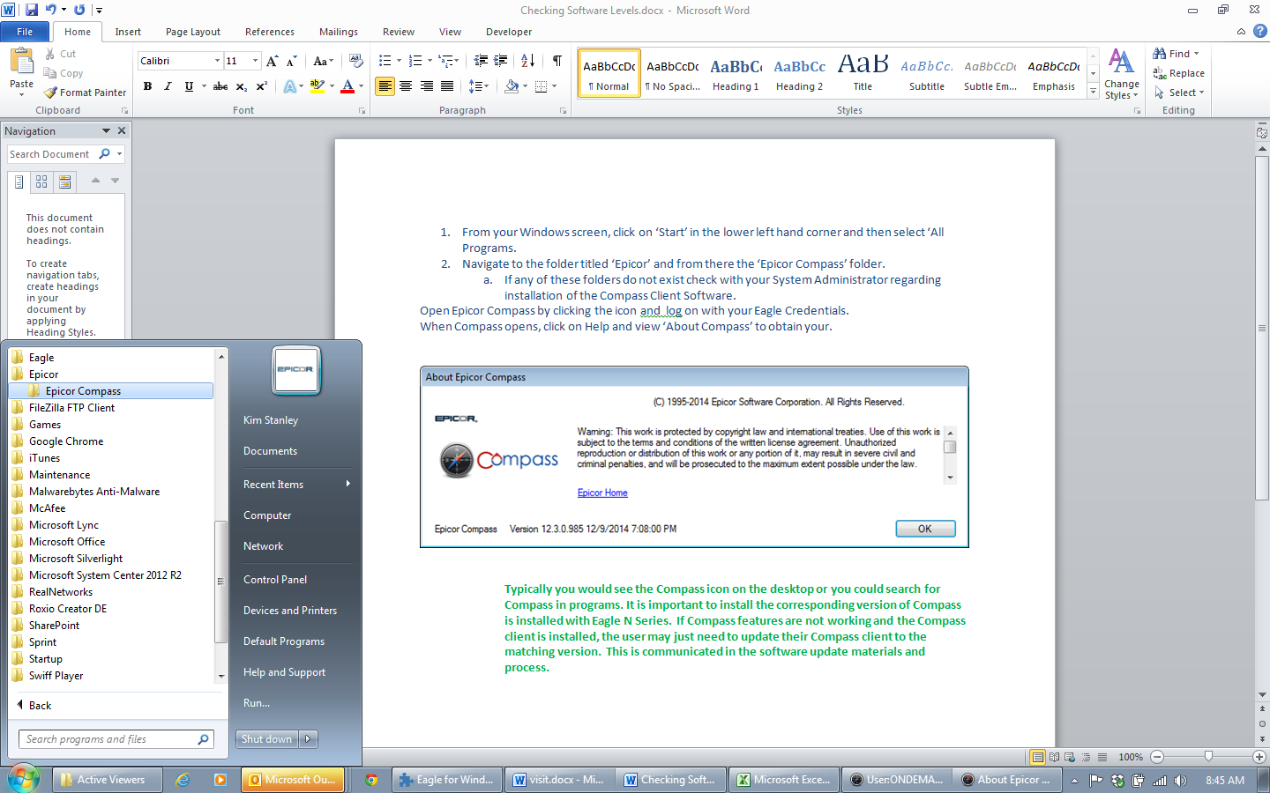

1. Open Epicor Compass by clicking the icon and log on with your Eagle Credentials.
2. When Compass opens, click on Help and then select ‘About Compass’ to obtain your Version.

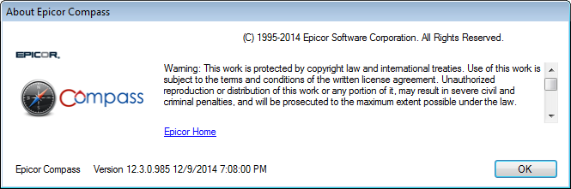

1. It is important to install the corresponding version of Compass is installed with Eagle N Series.  If Compass features are not working and the Compass client is installed, the user may just need to update their Compass client to the matching version.  This is communicated in the software update materials and process. Contact the Eagle Advice Line if your Eagle Active Viewer is not responding following an Eagle software update.