 |  |   Learning Solutions Center – Accessing and Registering for Classroom-Based Training
Our Learning Center is the place to be to make the most of your Epicor Eagle System, whether you are keeping up to date on new releases, you want to help training your new employees, or you want to register for Classroom-Based Training.

1 | Accessing Classroom-Based Training Events  - From your internet browser, go to http://ondemand.epicor.com  - At the login screen, use your iSupport login to access the site.  - If you do not have a login, click the link to register at http://isupport.activant.com. Once you receive a registration confirmation email, you can return to the Learning Website to enter your login information.
2 | Searching and Registering for Classes  - From the menu on the left hand side of the screen, click on Quick Views, and then Classroom-Based Training.  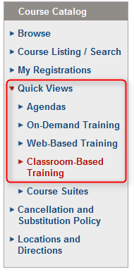  - Search for and select the class you want to attend, and then click the Register for this class hyperlink.  - The Registration Submission page will appear.  - Keep in mind that some courses are free of charge, and others have a fee. This will be reflected on the Registration Submission page. If the amount is $0.00 and you click submit, do not worry – you will not be charged a fee.  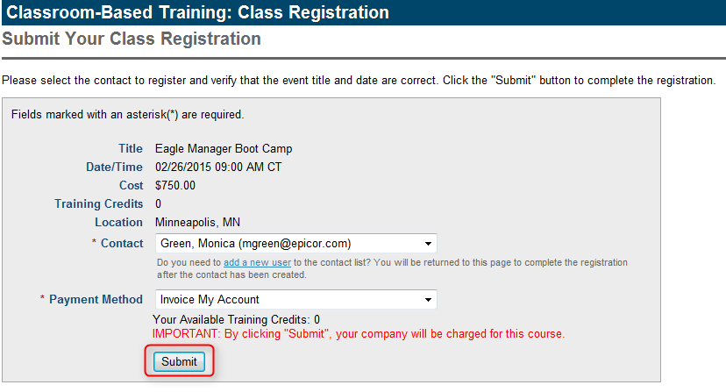  - Click Submit  - A Class Registrtion Confirmation screen will appear.
3 | After Registration:  After you register, and as you get closer to the event, you will receive e-mail communication from us with a timeline and agenda.  You can also use our Locations and Directions link to get the location address, utilize online mapping, and find nearby hotels. To access Locations and Directions:  - From the menu on the left hand side of the screen, click on Locations and Directions.  - You will see a list of all of our training facility addresses. If there are directions and hotel information available, simple click on the hyperlink below to named location to access that information. 