Label Printing Options

Please review the following options related to printing labels from a batch file.

* ID 5824
* ID 5825
* ID 7320

Options ID 5824 can be set to prompt you to delete the label batch.

ID 7320 can be configured to purge batches after a given number of days. If option 7320 is left blank any batches which are not manually deleted stay on the system.

Options ID 5825 can be set to create separate label batches by store from RBL or when using the Labels button in MIP and IPC.

There are several new places in Eagle N Series where the ‘Labels ‘button can be found to directly trigger the ‘Labels’ dialog window.

1. Inventory Viewer – all lookups
2. Bin Label Changes Viewer
3. Purchasing (MPO) – Posting
4. Purchasing (MPO) - Receiving
5. Purchase Order Detail Viewer

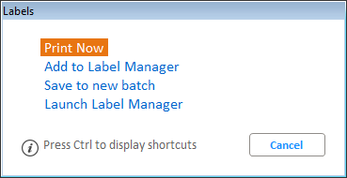

1. Purchase Order Archive Detail Viewer
2. MIP
3. IPC