In order to create a Dynamic Promotion Type 11 you must have the following three things on your system:

1. Customer Loyalty
2. Dynamic Promotions
3. Dynamic Coupons

If you are unsure about your system configuration, contact your Epicor Customer Account Manager

Option ID 1182, ‘Loyalty Program’ will need to be set to something other than None.

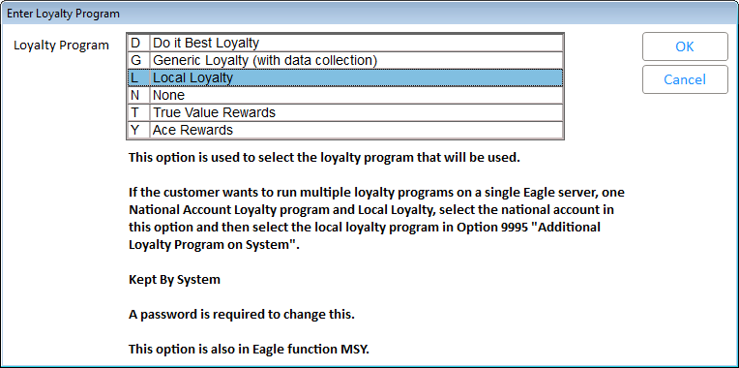

Options ID 1081, ‘Dynamic Promotions on System’ will need to be set to Yes.

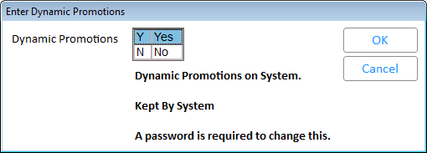

Options ID 9871, ‘Dynamic Coupons on System’, will need to be set to Yes.

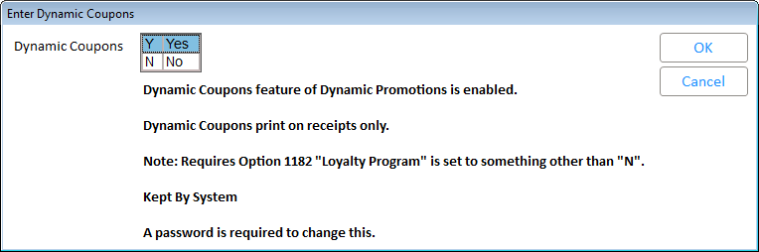

There are several Security Bits associated with the set up and use of Dynamic Promotions. Review the list below prior to accessing this function.

* Security Bit 965
* Security Bit 966
* Security Bit 1028
* Security Bit 1029
* Security Bit 1112

